Clayton DeSimone

Thesis/Capstone

Final Project

5/2/2024

**Dates of work for Helena Hunters**

**& Anglers Association website**

Below are all the dates along with screenshots and descriptions of the work I performed on the [HHAA website](https://helenahuntersandanglers.org/). This is a comprehensive list and there were other small changes/updates that I made that may not have been included based on the volume of edits made through the course of the semester.

2/29/24

Initial analysis of Helena Hunters & Anglers website. Uses WordPress as CMS. Outdated WP version; deleted calendar plugin needed update not available on current version of WP; updated others. My mom, Gayle, spoke with Kathryn (original sight builder) about updating WP.

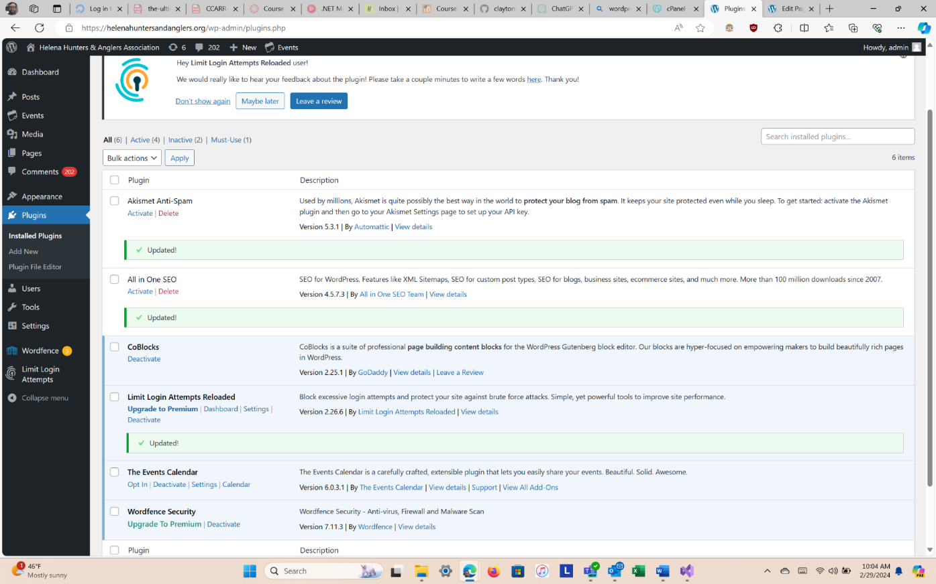

Deactivated and deleted The Events Calendar.

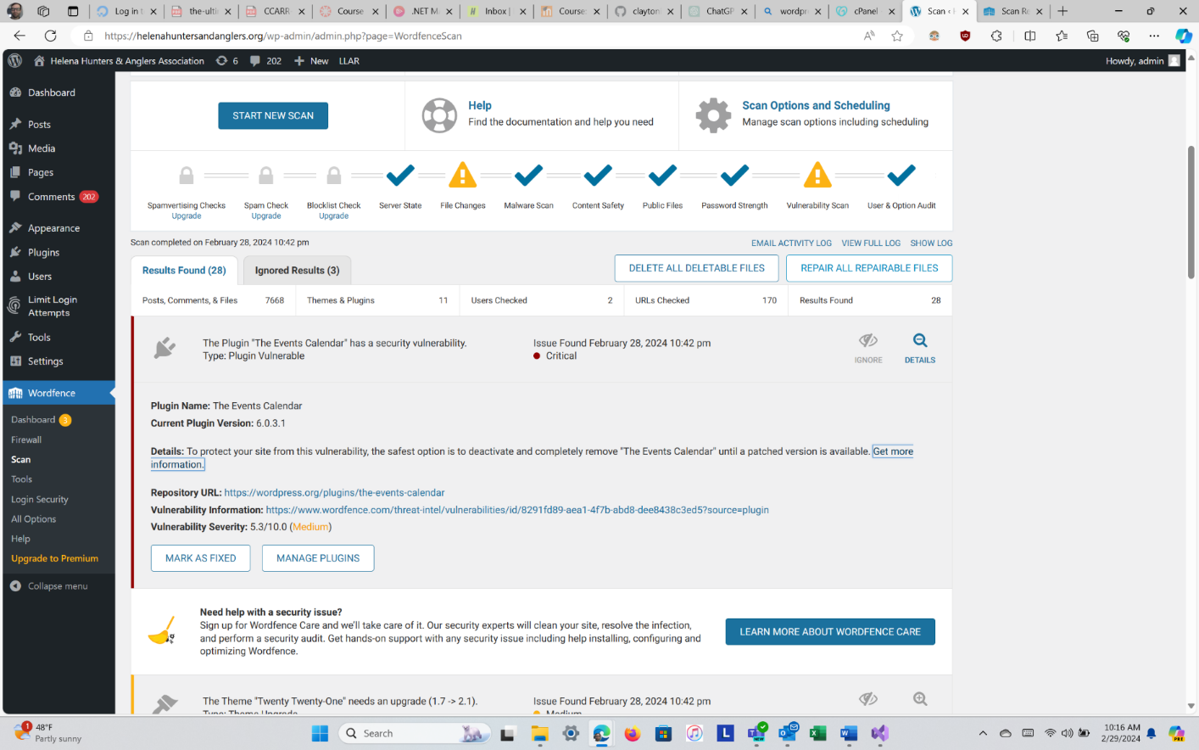

3/4/24

Updated to current version of WordPress—4.3.1? Changed logo on background for all pages. Learned more of the navigation of WP.

3/12/24

Upgraded plugins through cPanel from GoDaddy. Changed order in About dropdown in primary menu. Link Cinnabar Foundation and Western Environmental Law Center logos to appropriate links. Fixed Become a Member link. Swapped out logos.

cPanel—updates needed in WordPress.

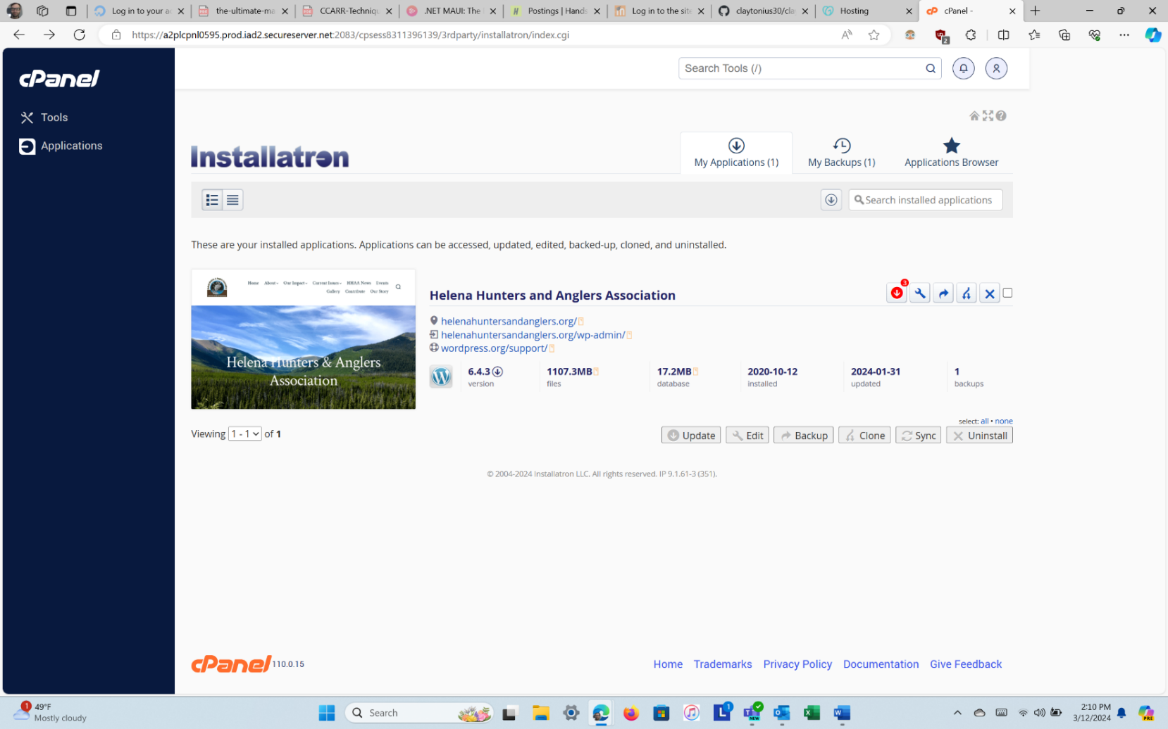

Updated plugins through cPanel.

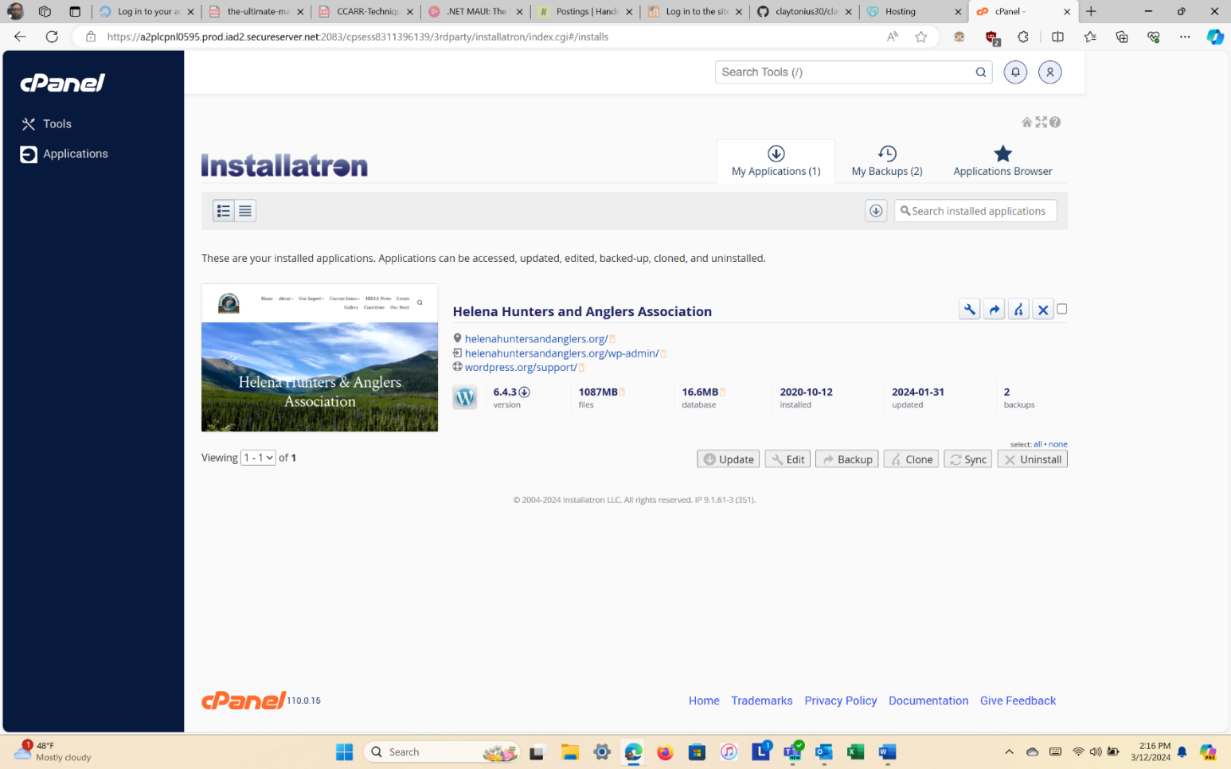

Performed scan through Wordfence.

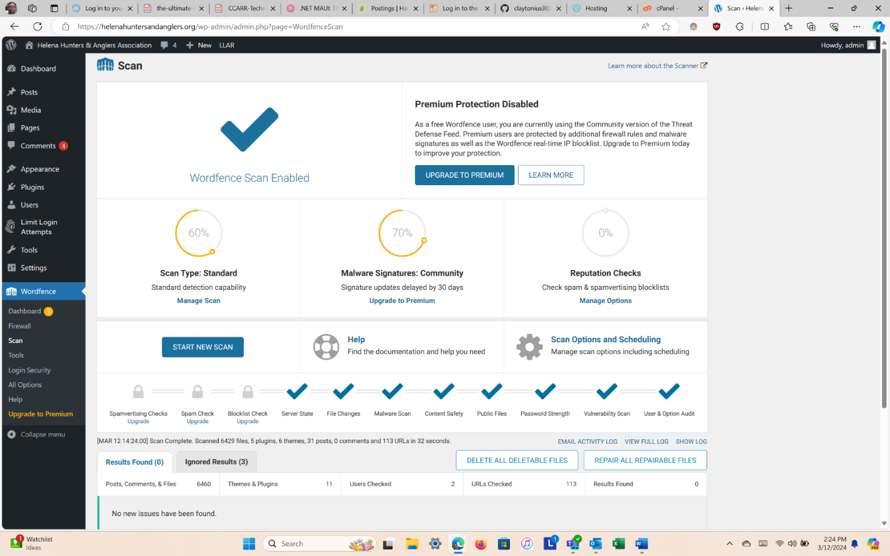

Reordered ‘About’ primary menu.

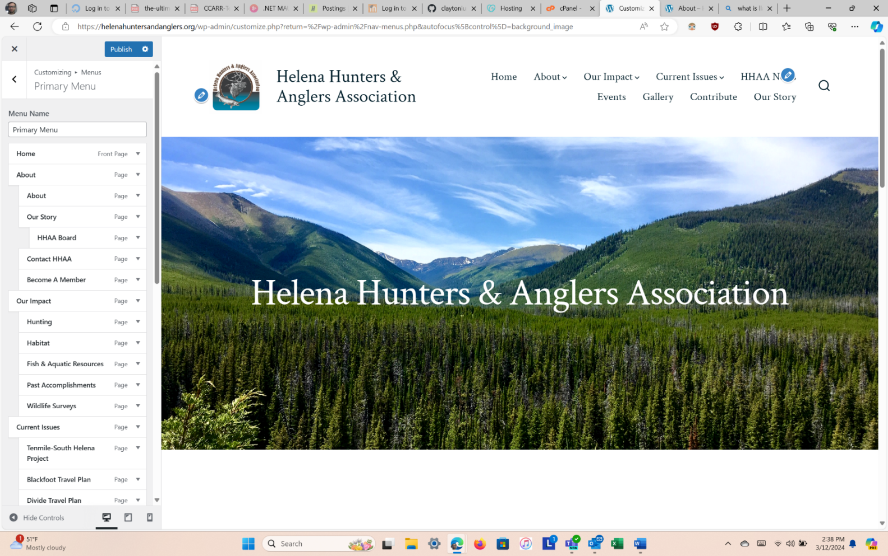

Added link to Cinnabar logo.

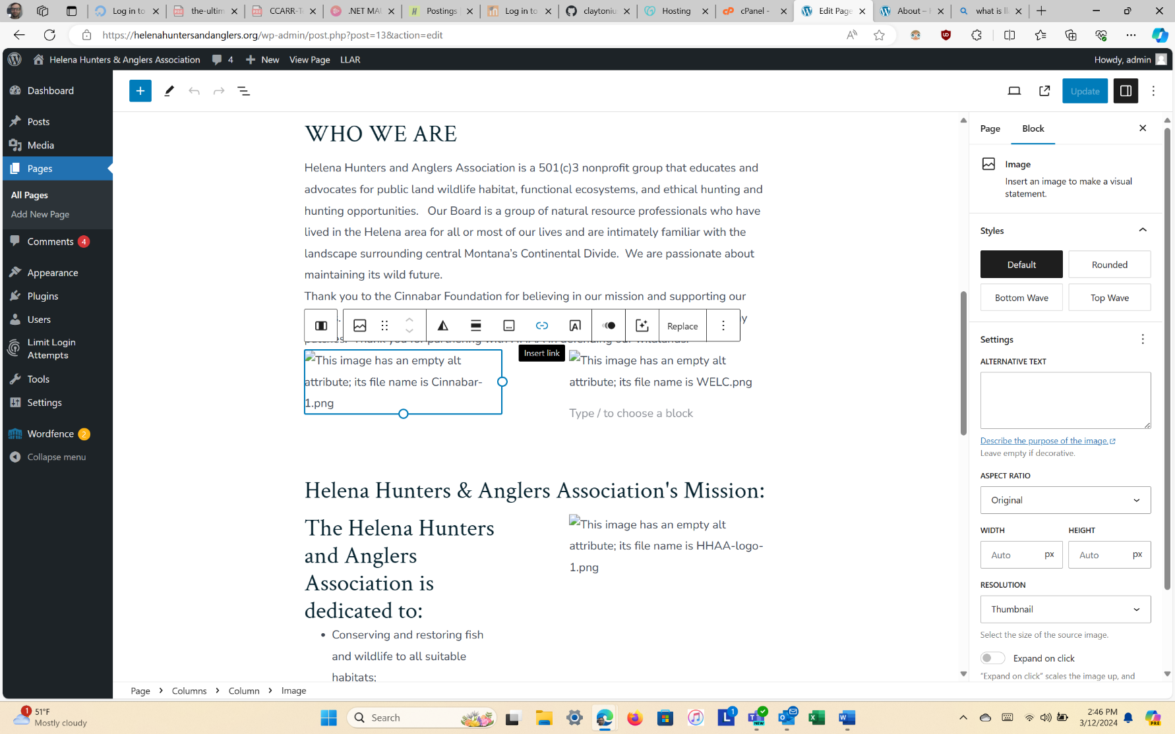

Fixed ‘Become a Member’ link.

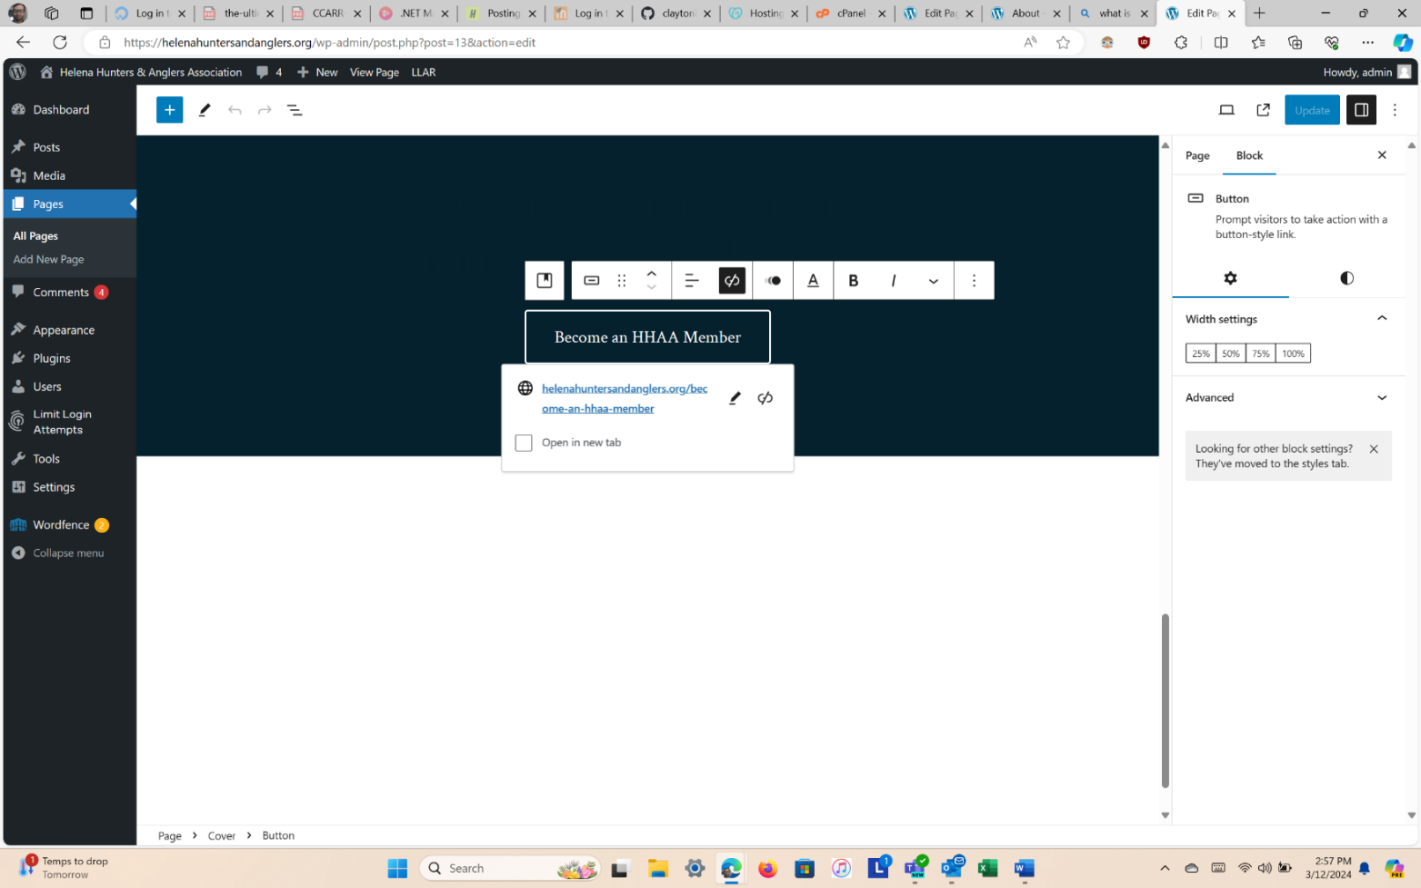

Swapped out logo on ‘About’ page.

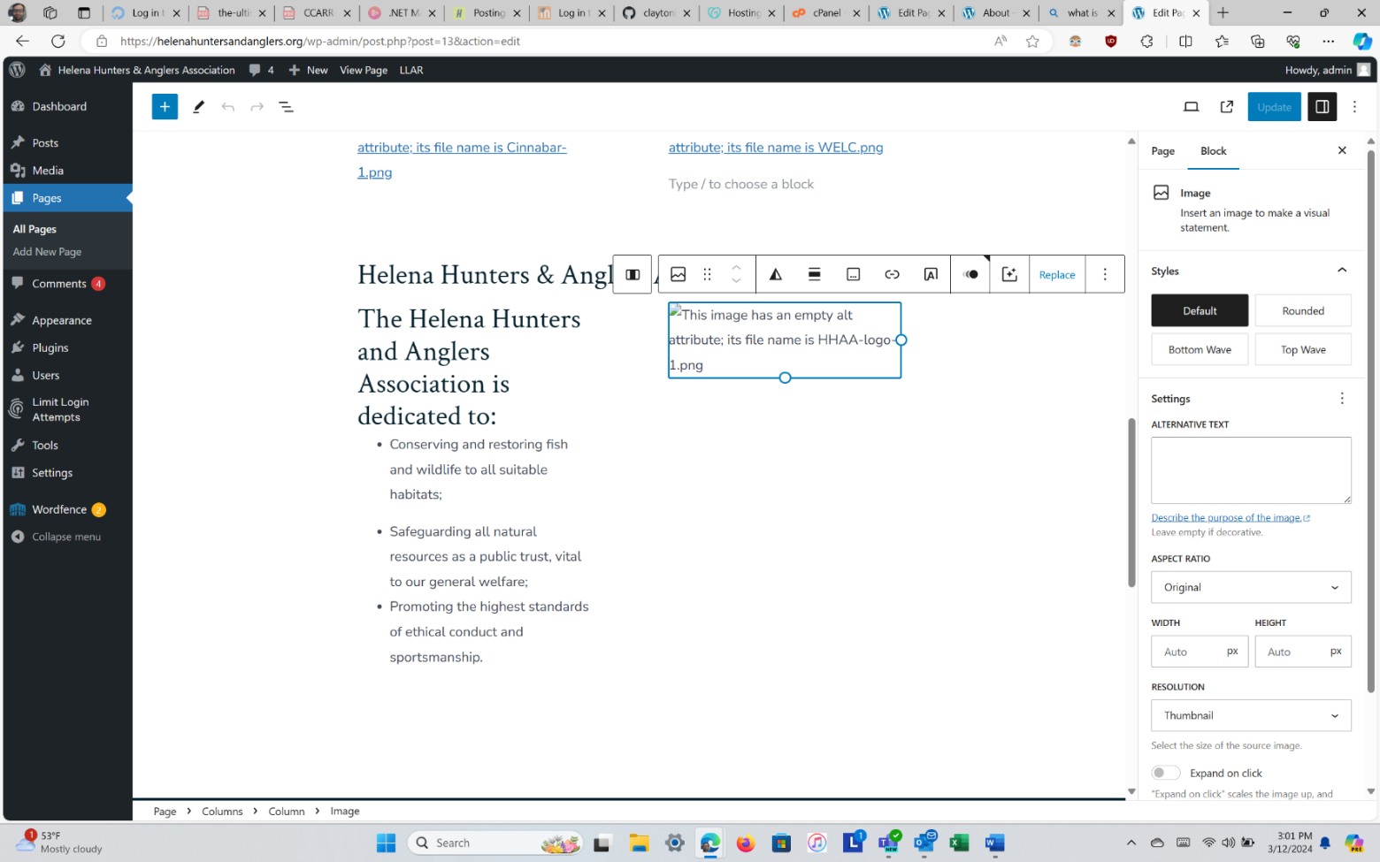

3/16/24

Adjusted formatting on Our Story page. Added hyperlinks to various images.

3/19/24

Adjusted picture on About🡪Our Story page.

Needed to fix image distortion.

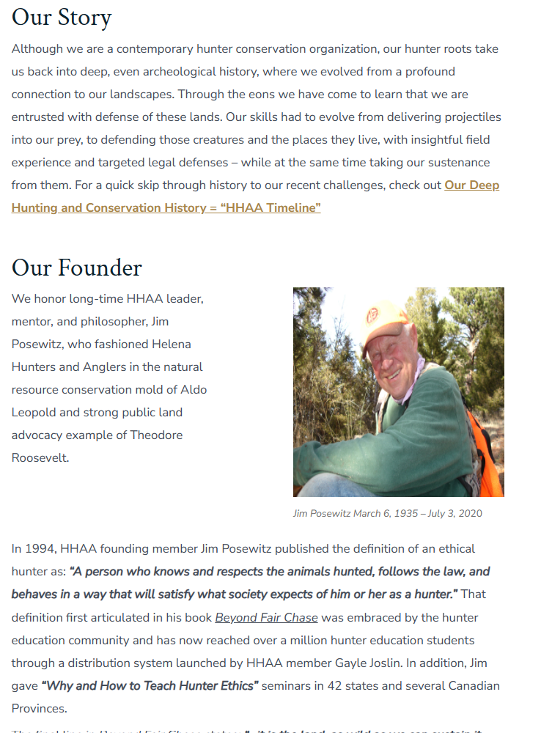

Fixed image distortion.

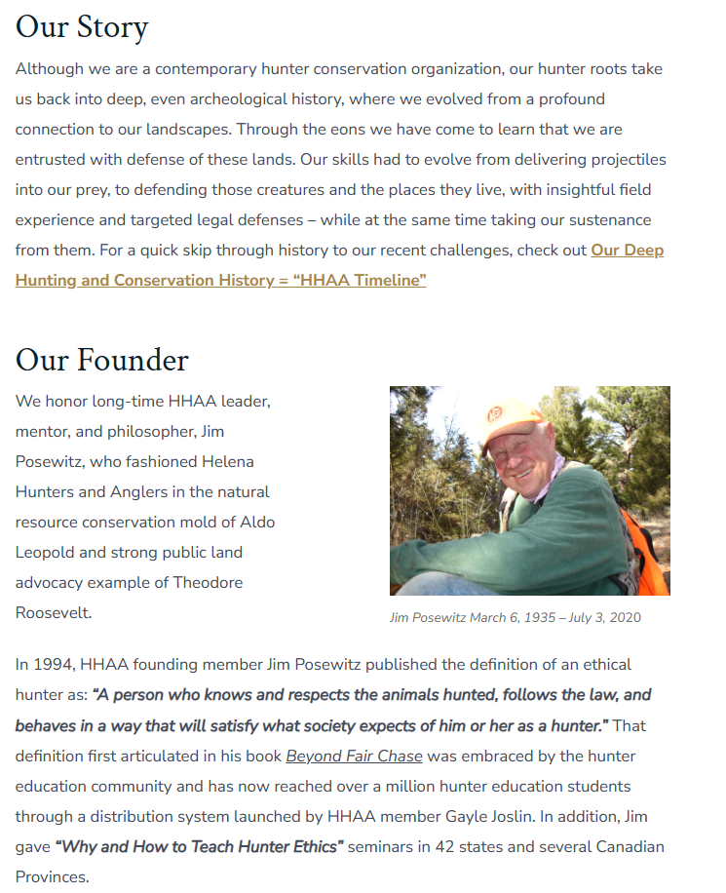

3/30/24

Worked with Kathryn (who built website) to further understand website structure and formatting; learned how PayPal is used to take donation—PayPal link is provided as hyperlink; PayPal management done through PayPal directly.

Backups of website done through WordPress. Control login security through ‘Limit Login Attempts’🡪Logs🡪Deny List in WP. Can add my home IP address to list accepted list. In Wordfence, can block IP by country; add to list. Also block states, every state blocked except Montana.

To add a webpage, go to Menus🡪Appearance; Add page to existing menu.

Disabled automatic email being sent to admin when a new comment is posted.

Added president’s letter and link from home page to blog page (News).

In site settings, replaced Kathryn’s name with mine (Clayton) so my name is in the footer of each page.

Adjusted ordering for News posts, disabled sticky posts to show in reverse chronological order.

Re-added the event calendar. Calendar links to specified events.

Fixed span tag in template-tags.php file. Adjusted alignment for horizontal pictures.

Update plugins in WordPress.

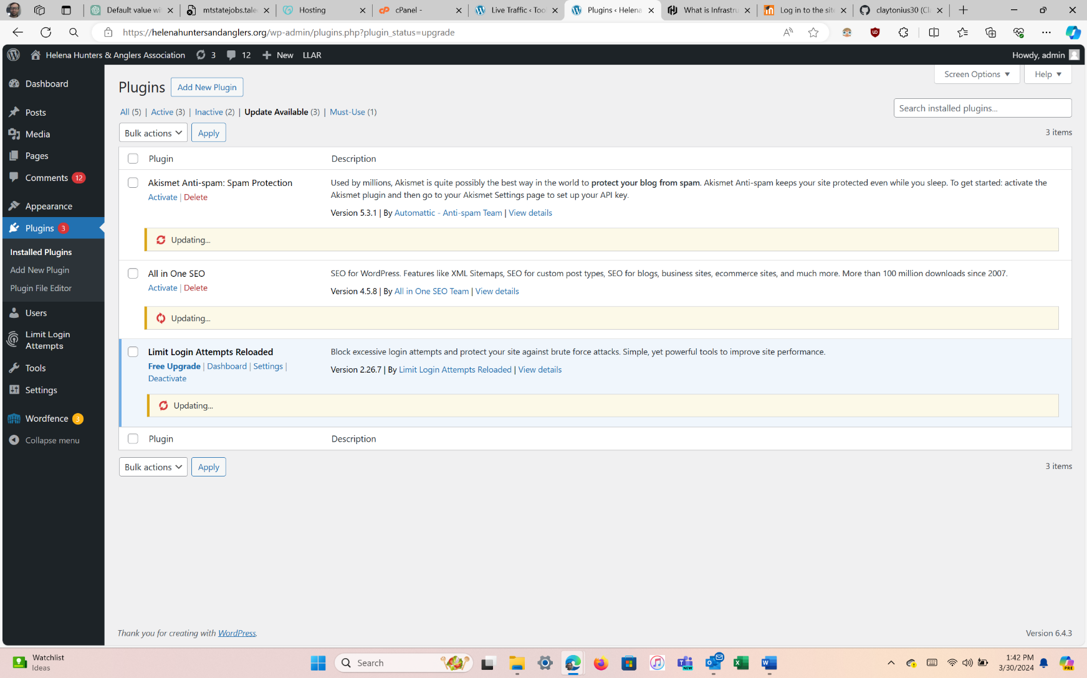

Identified PayPal link.

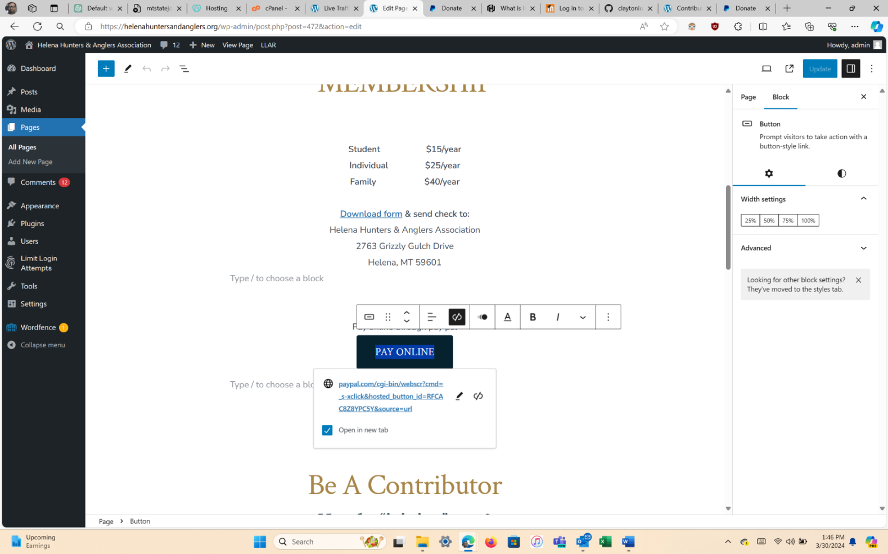

Needed to fix span tag condition in template-tags.php file.

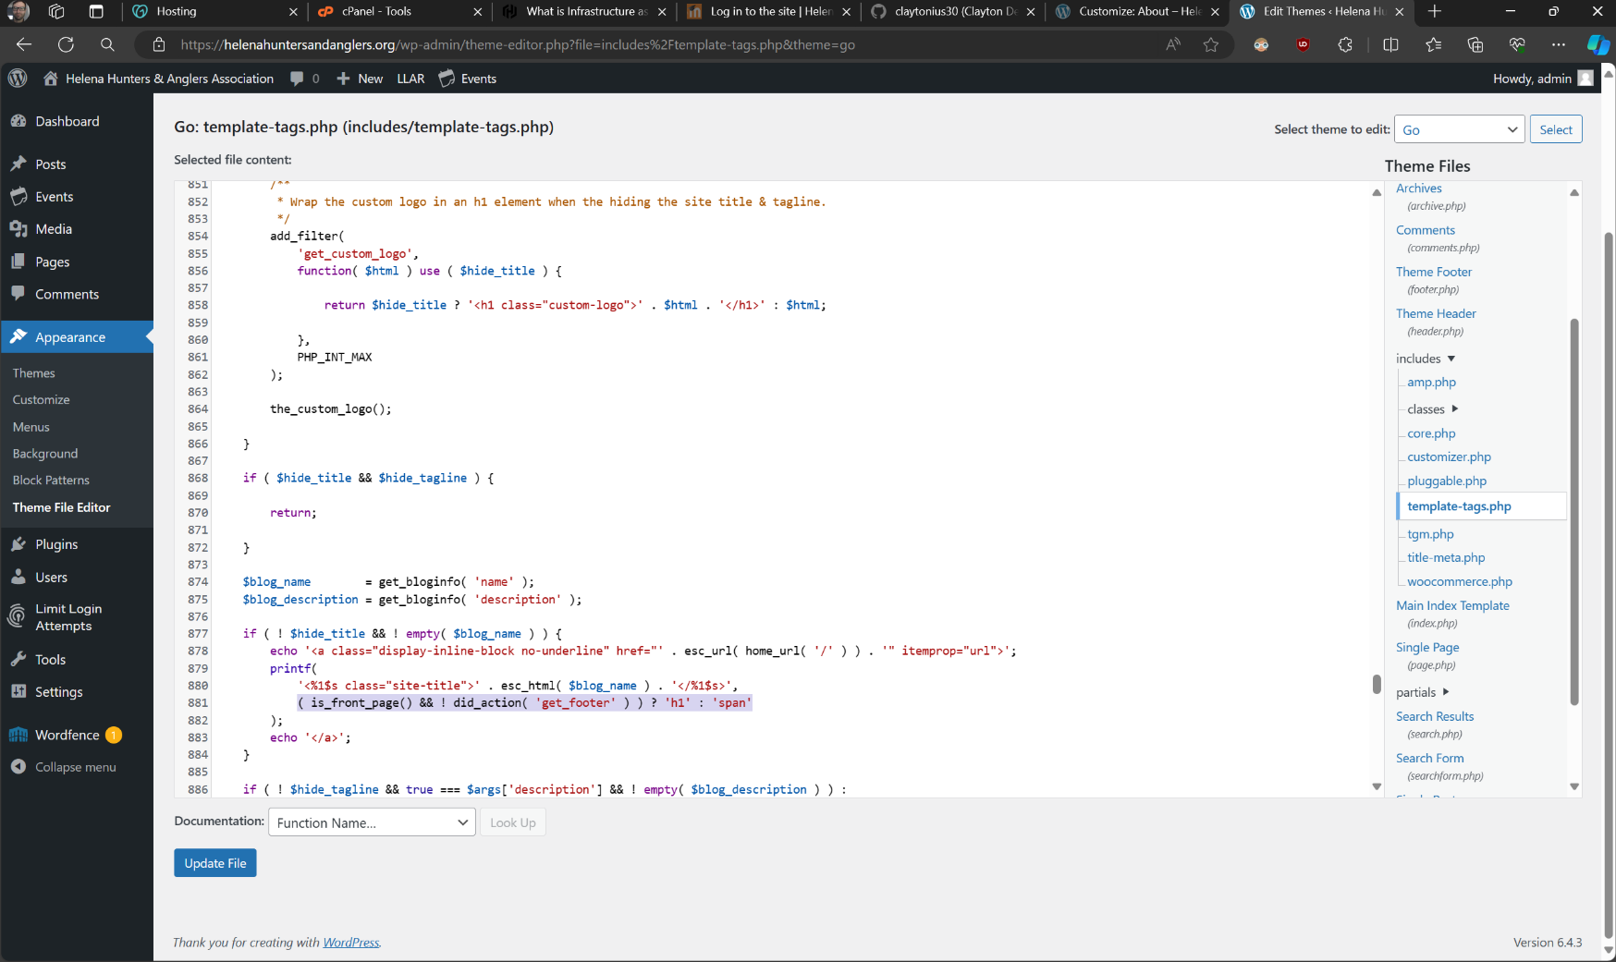

Removed condition to only display h1 tag on header file.

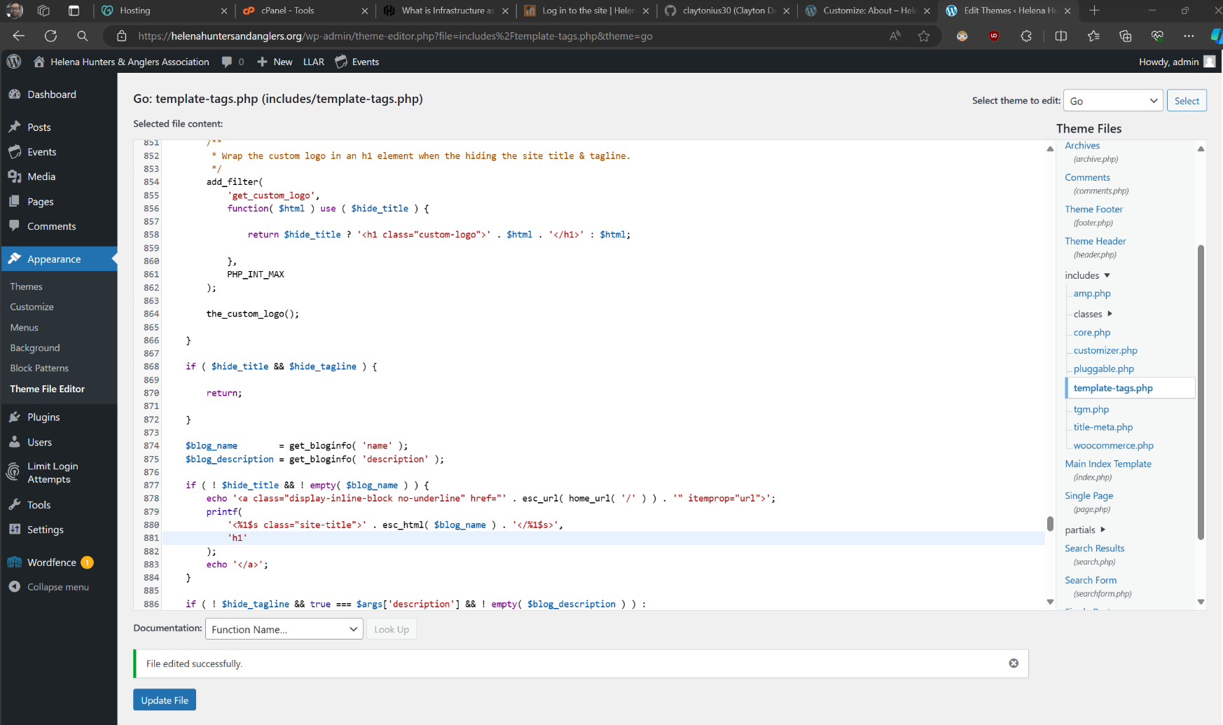

Centered horizontal pictures alignment.

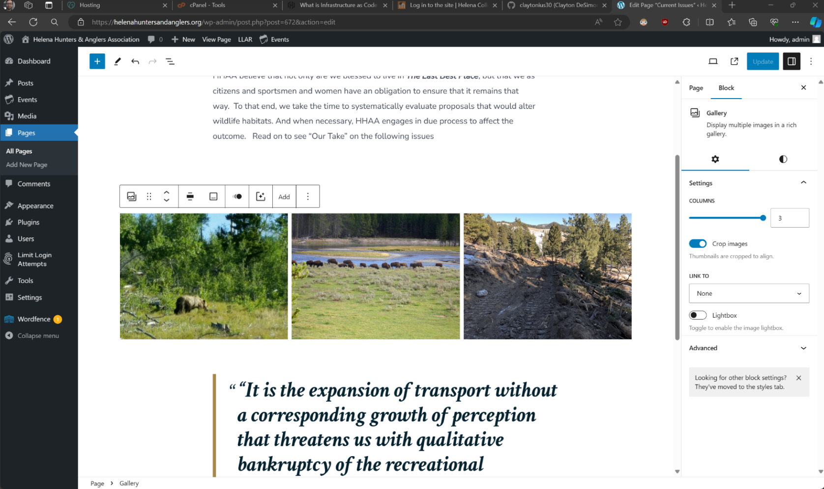

4/6/24

Updated to WordPress 6.5. Removed the “Leave a reply” section at bottom of each article in News. Fixed span tag issue that reoccurred after WP update. Fixed spacing between paragraphs by using ‘Spacer’ block (WordPress lingo). Fixed several hyperlinks.

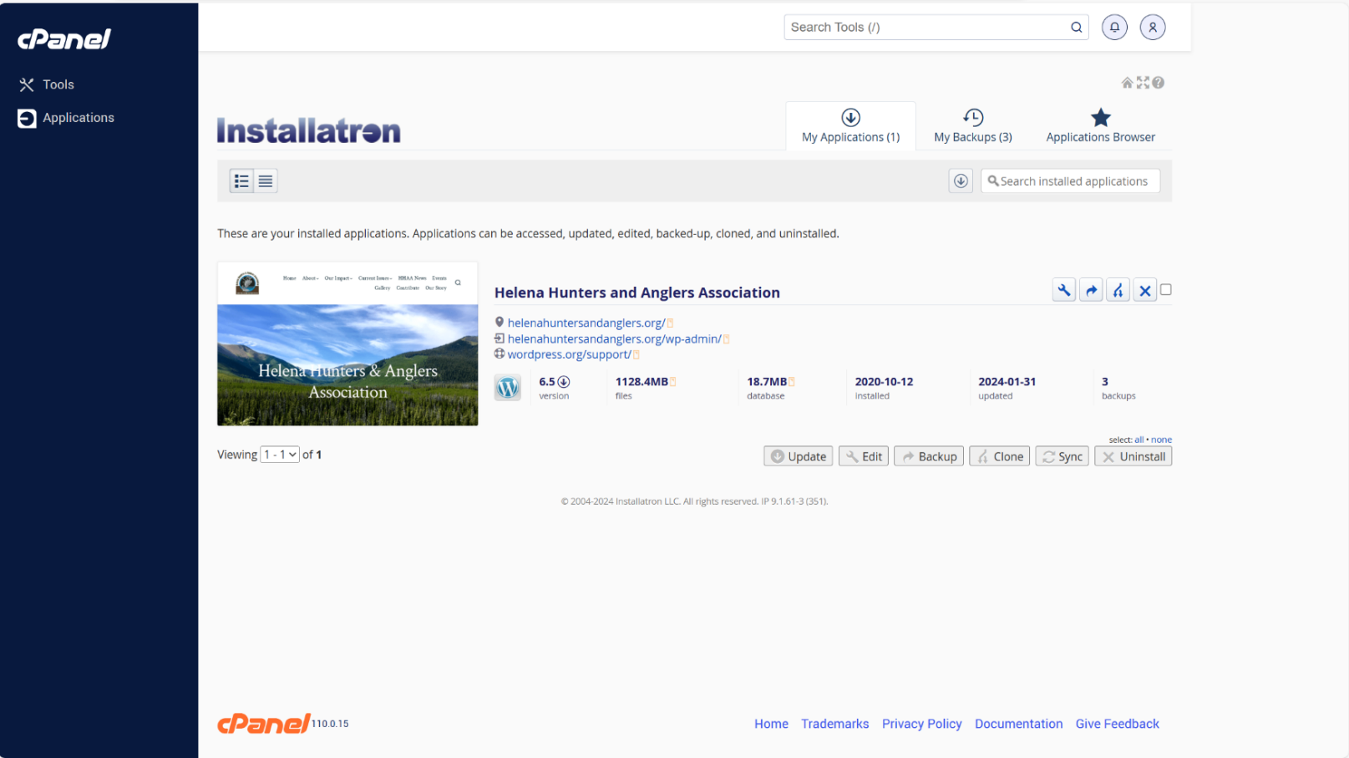

Alignment of text in header is wrapping too much (‘Anglers’ is almost touching the logo)

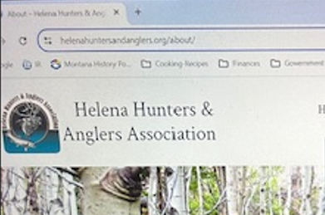

Needed to fix span tag again after WP update in template-tags.php file.

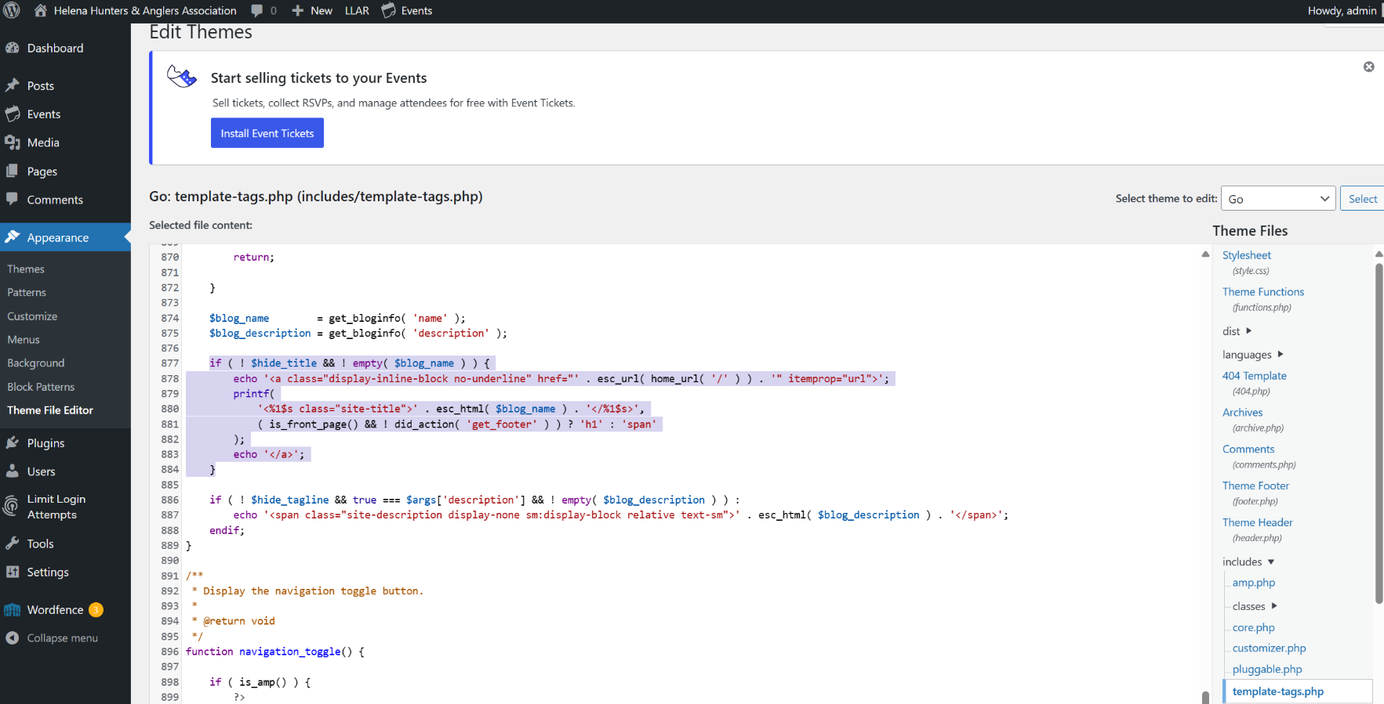

Added condition statement in comments.php file to disable comment posting on blog page.

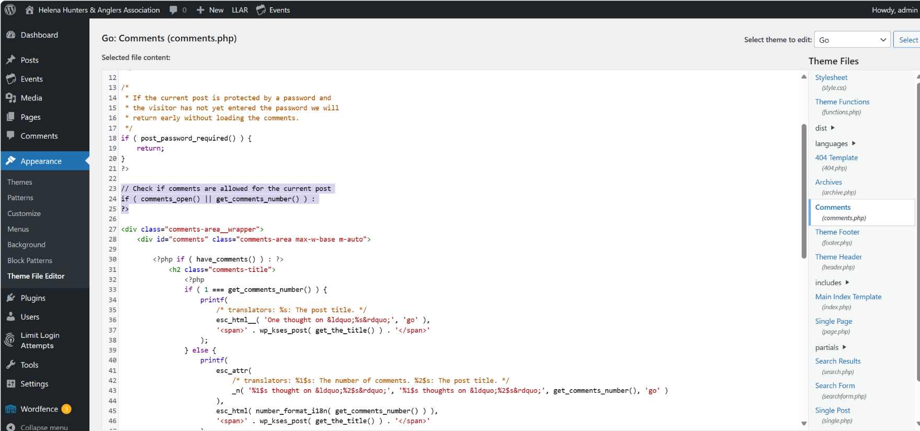

(End tag for condition statement)

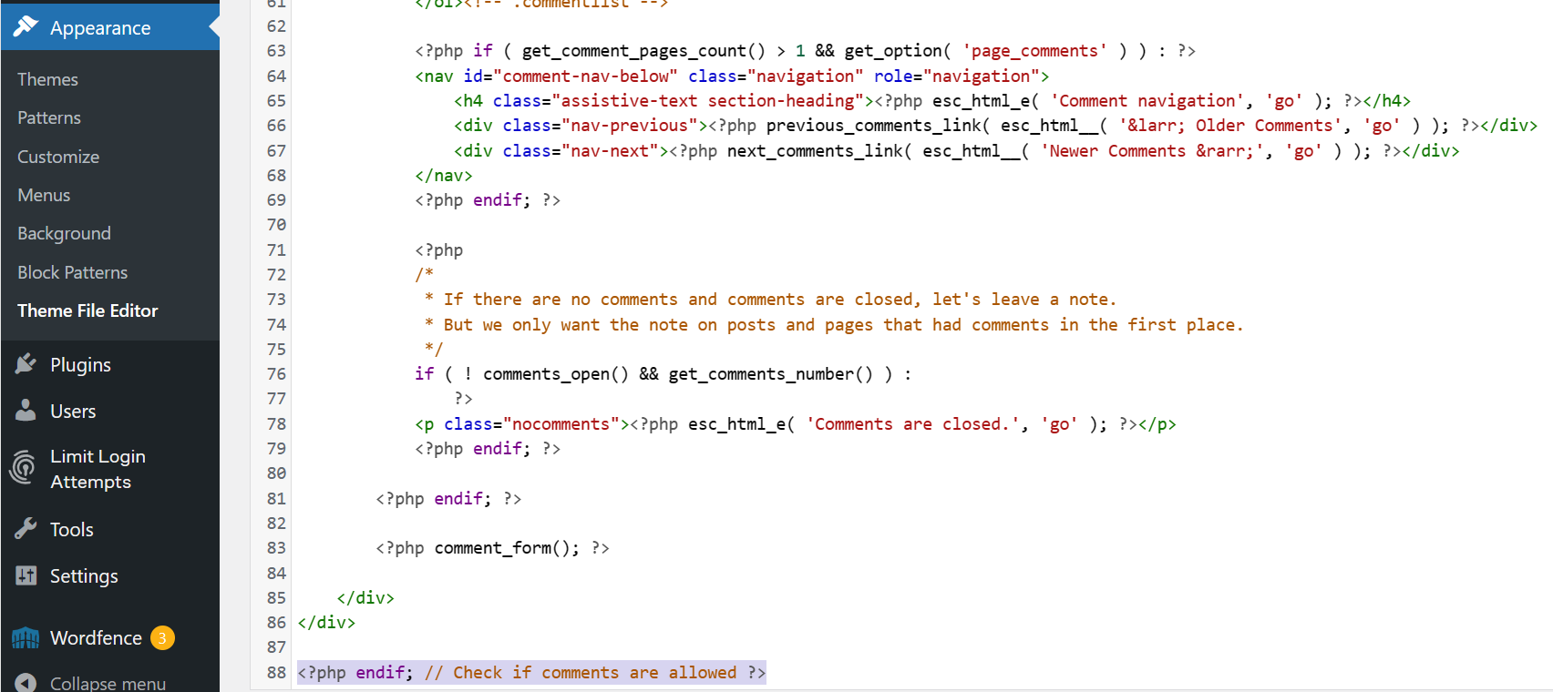

Added spacing between paragraphs using ‘Spacer’ block. (Could not ad <br> tag within existing HTML)

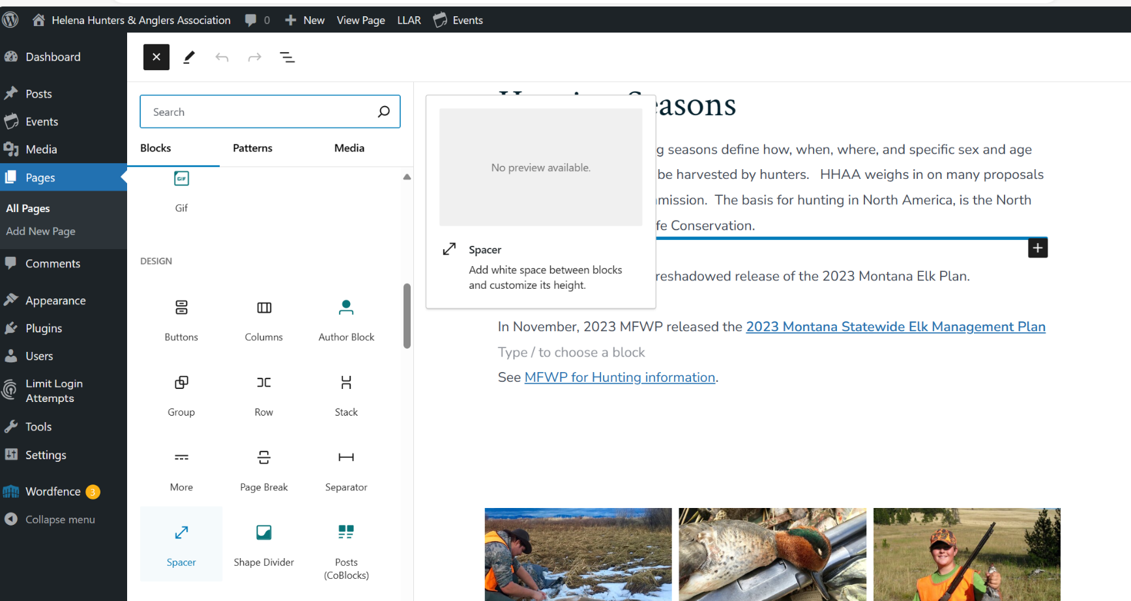

Fixed hyperlinks on Hunters page.

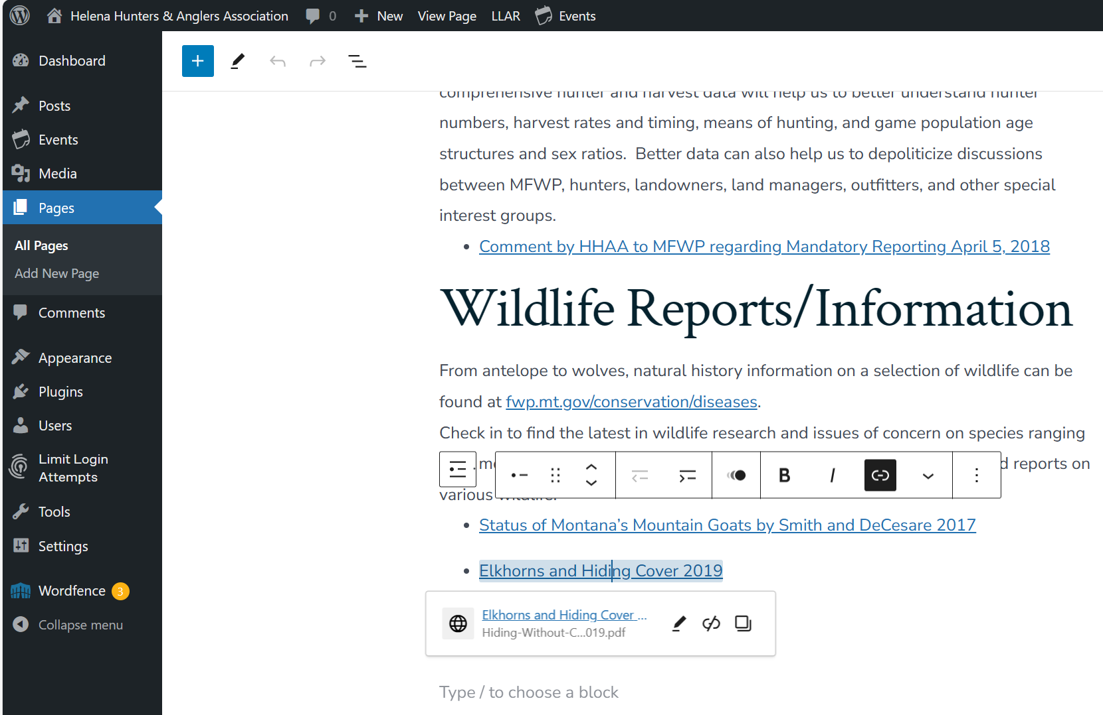

4/7/24

Made Welcome article ‘sticky’ to stay at top of Posts.

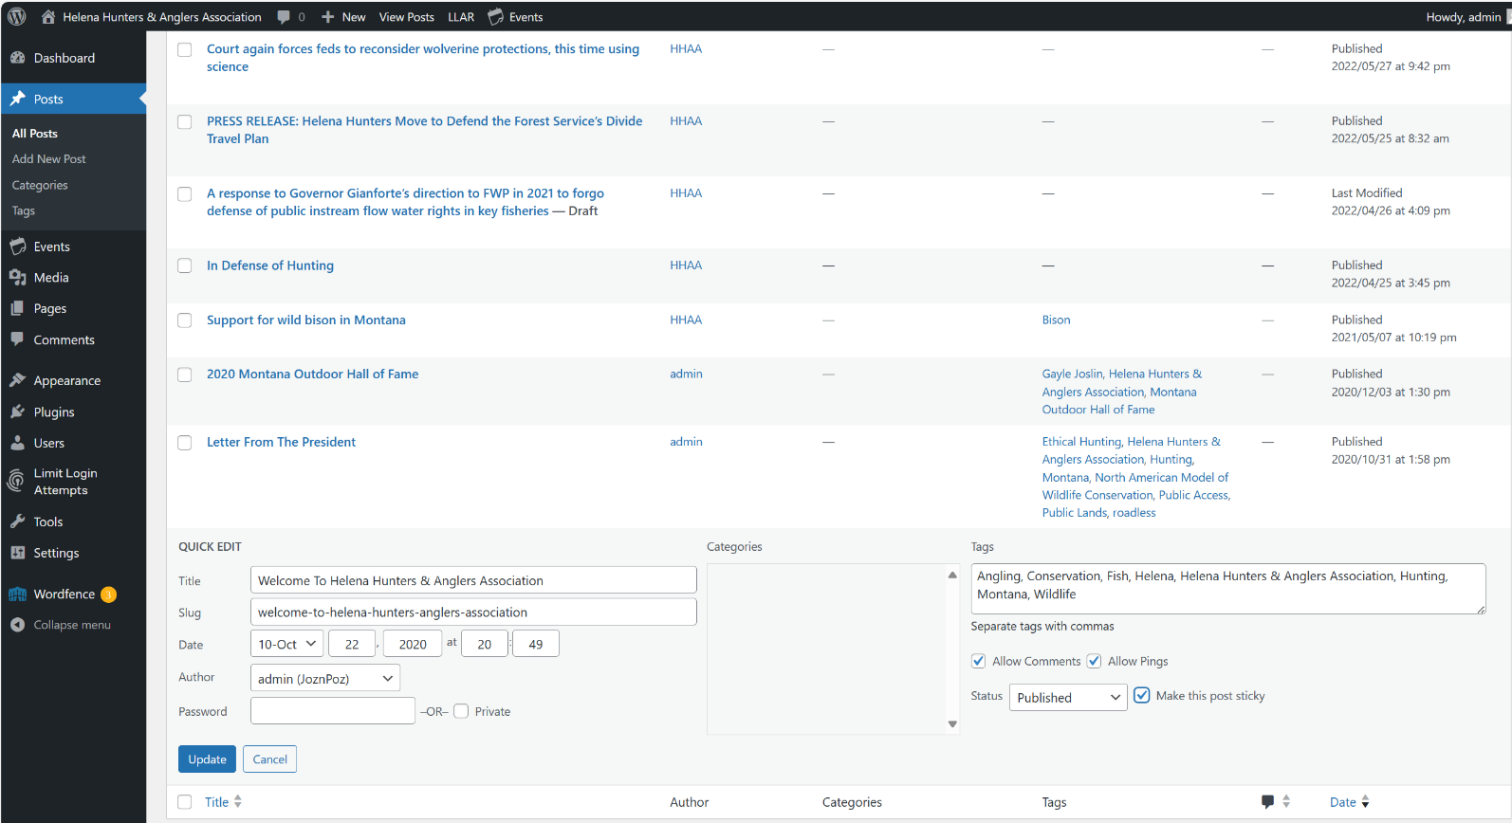

Added my email and name as admin user author.

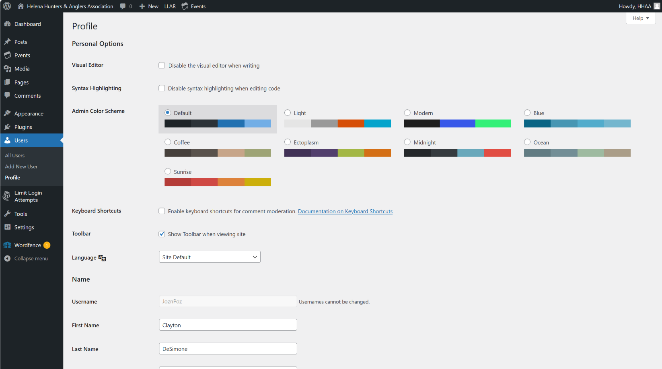

Removed comment section from each post.

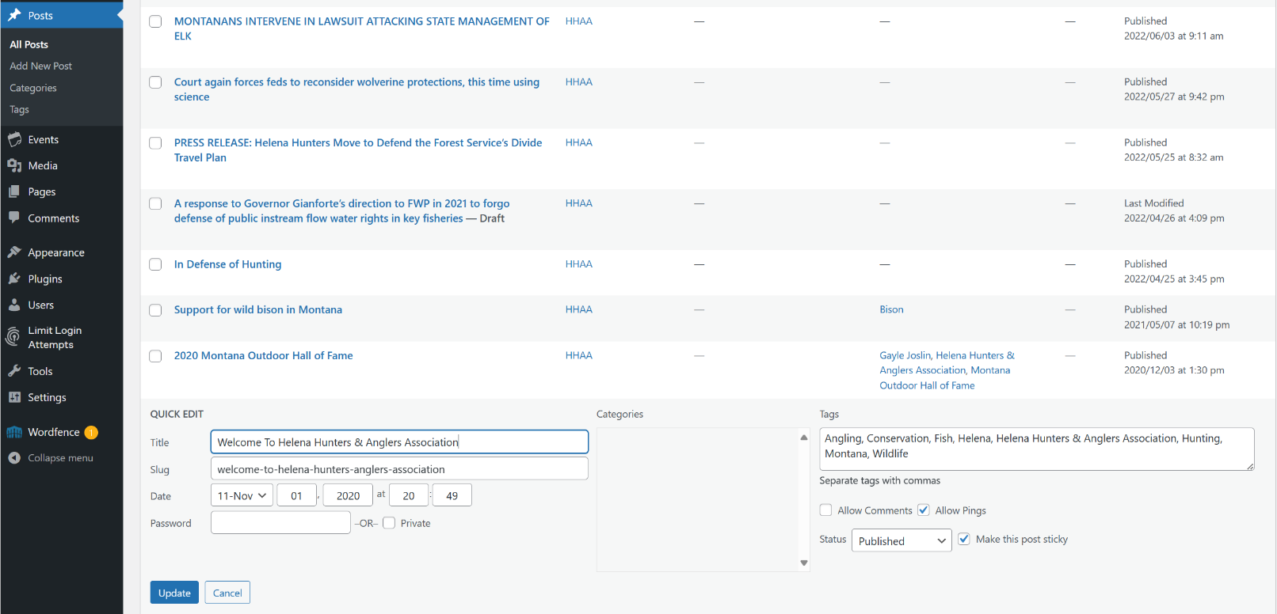

Added a new post to HHAA News.

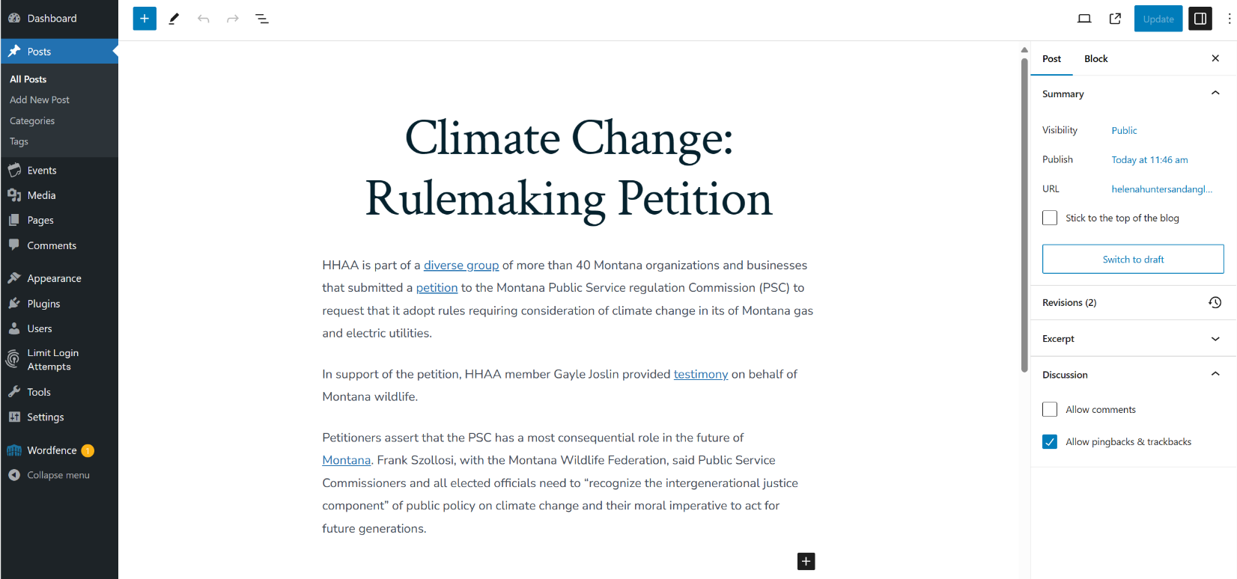

Removed post and placed into Hunting page.

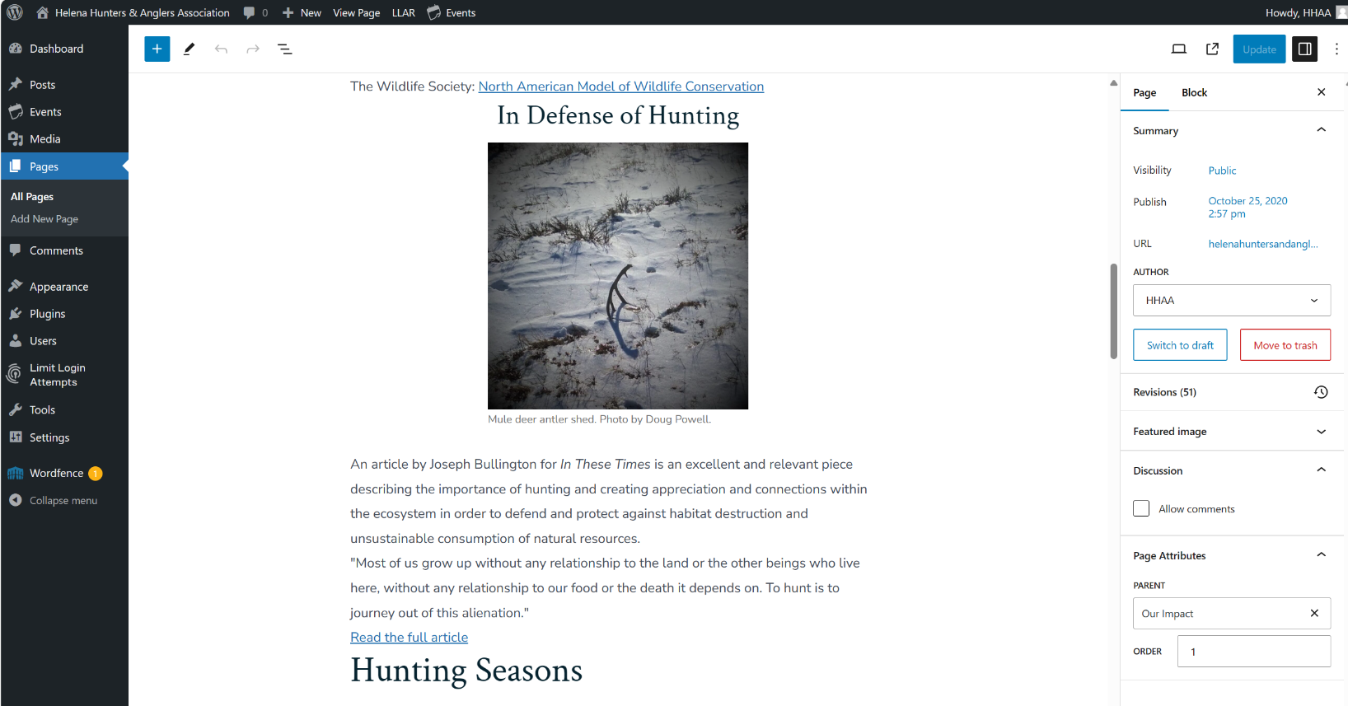

Changed post heading from all caps.

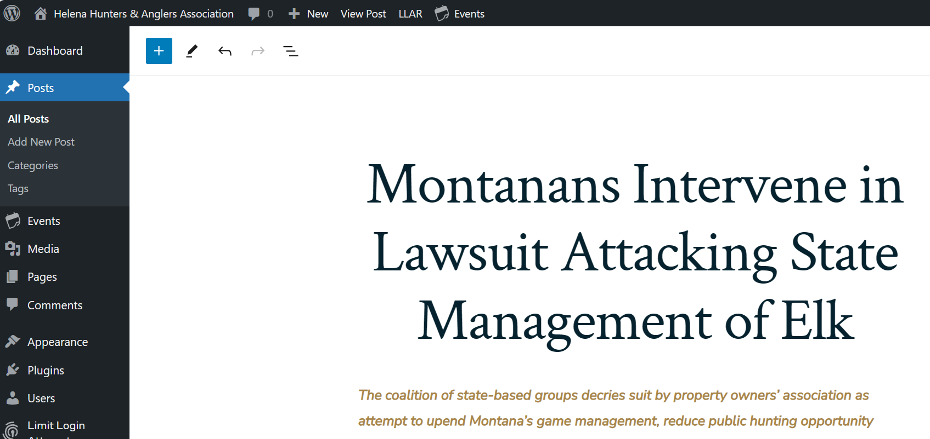

Added draft post and reordered items in Posts (HHAA News).

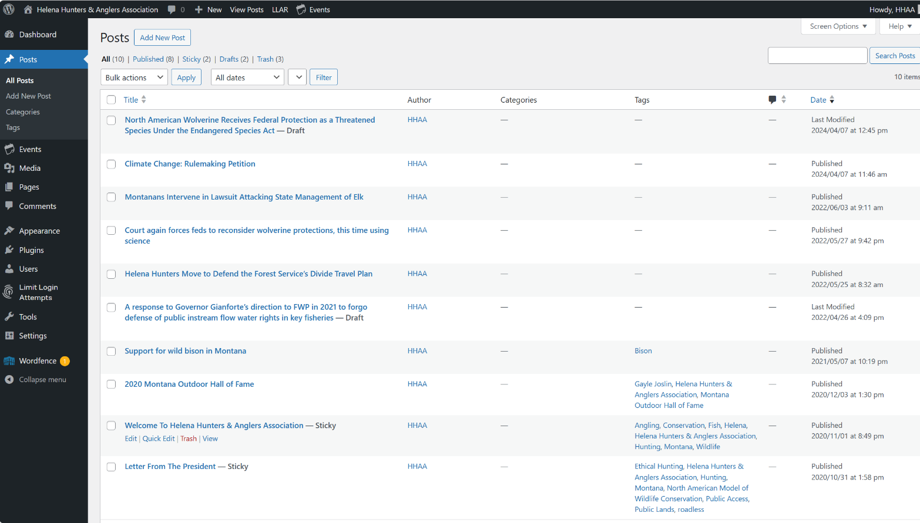

Made edits on Outdoor Hall of Fame post.

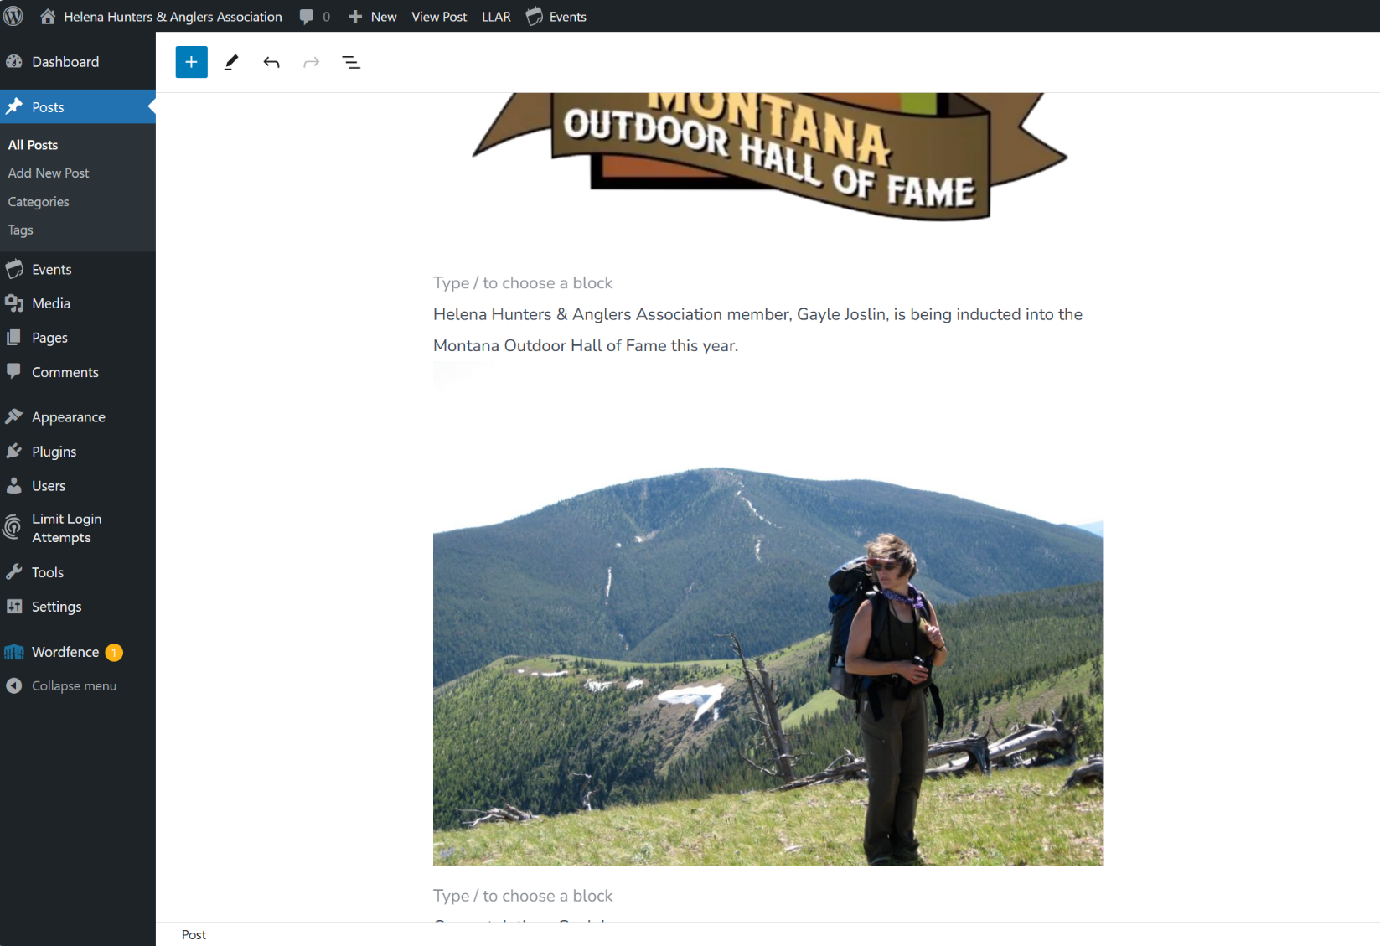

Put double quotes on Current Issues page.

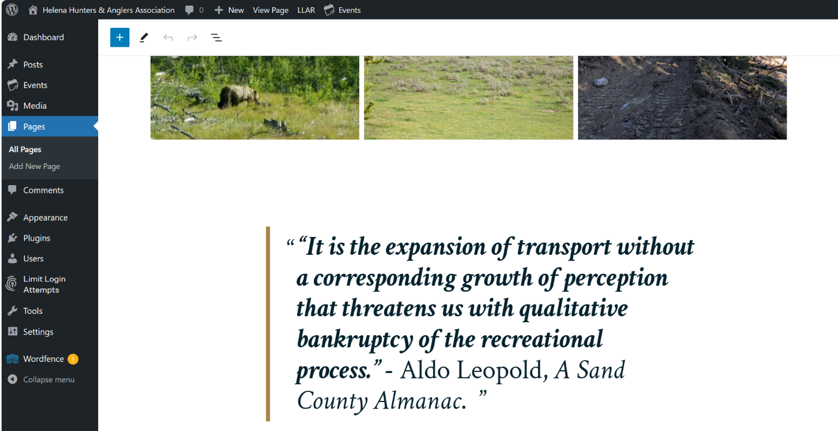

Changing blockquote caption size in Go theme file.

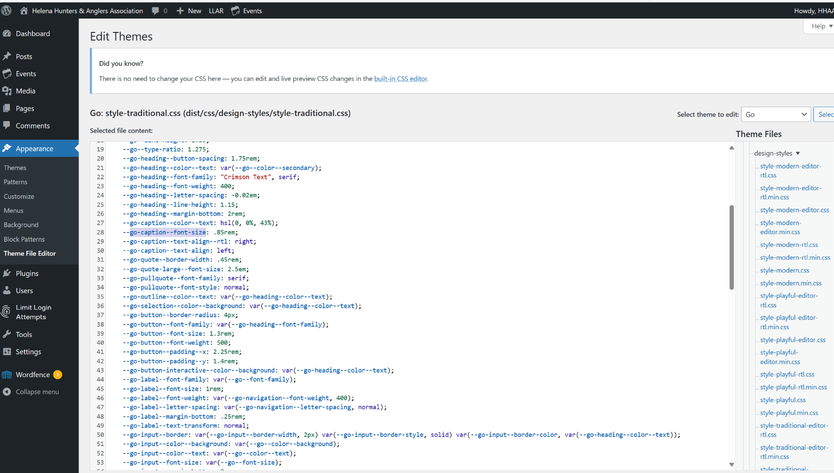

Added events to calendar.

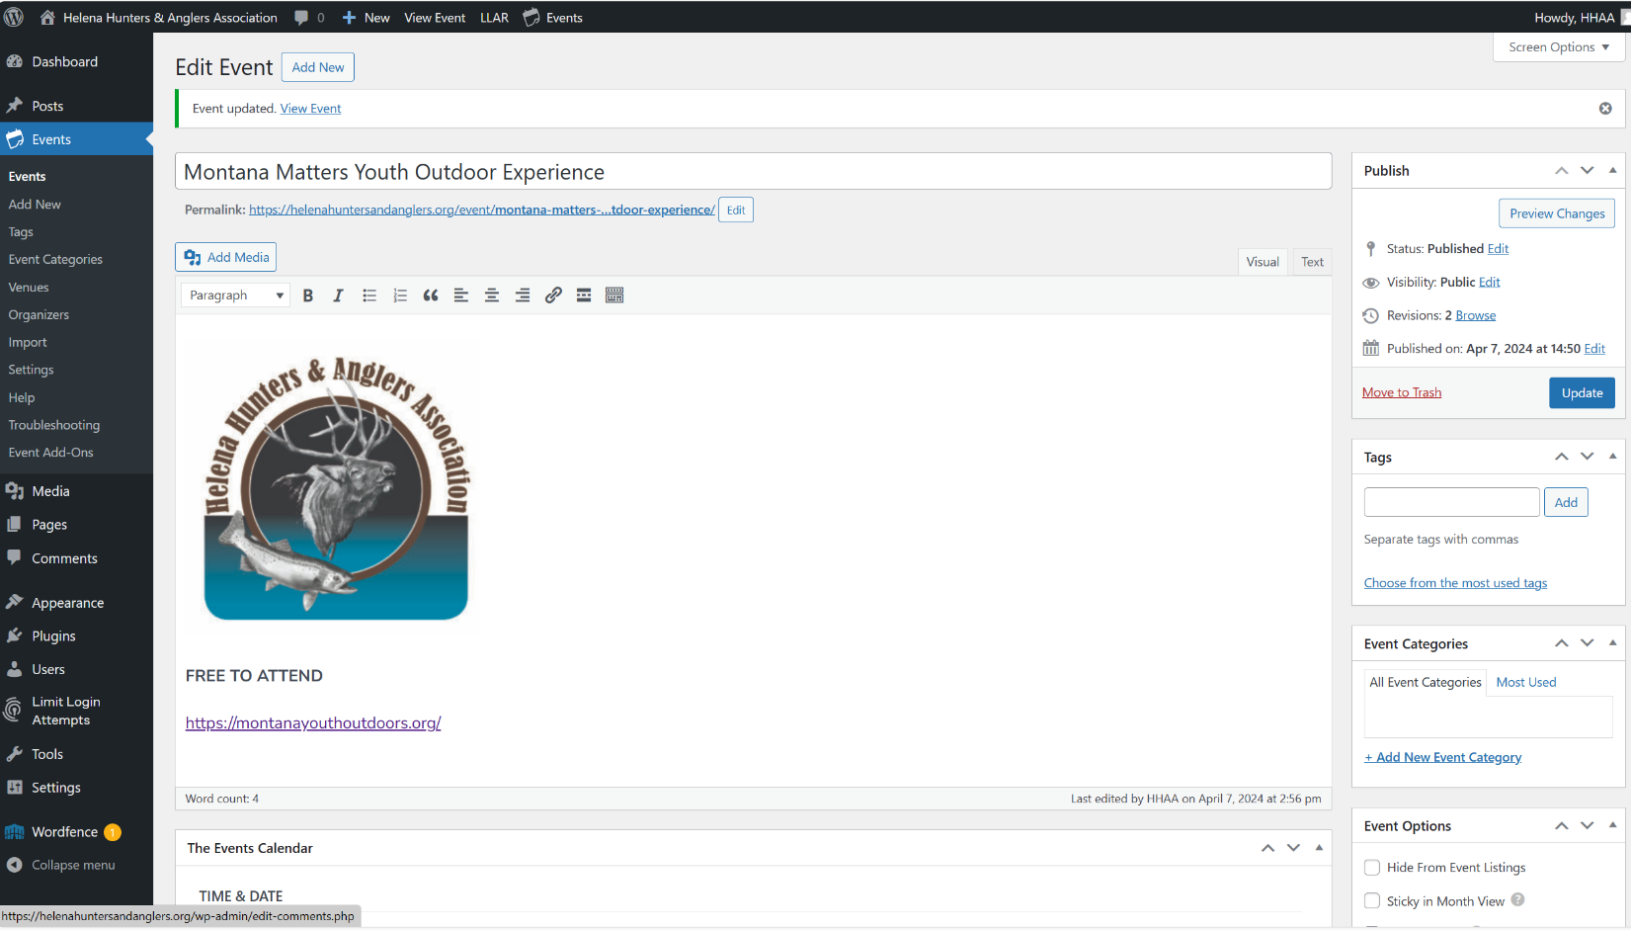

Found citation font size folder location.

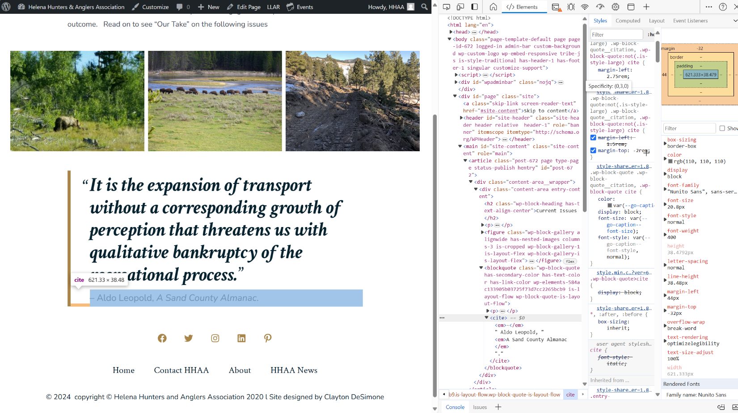

Citation file added style rule.

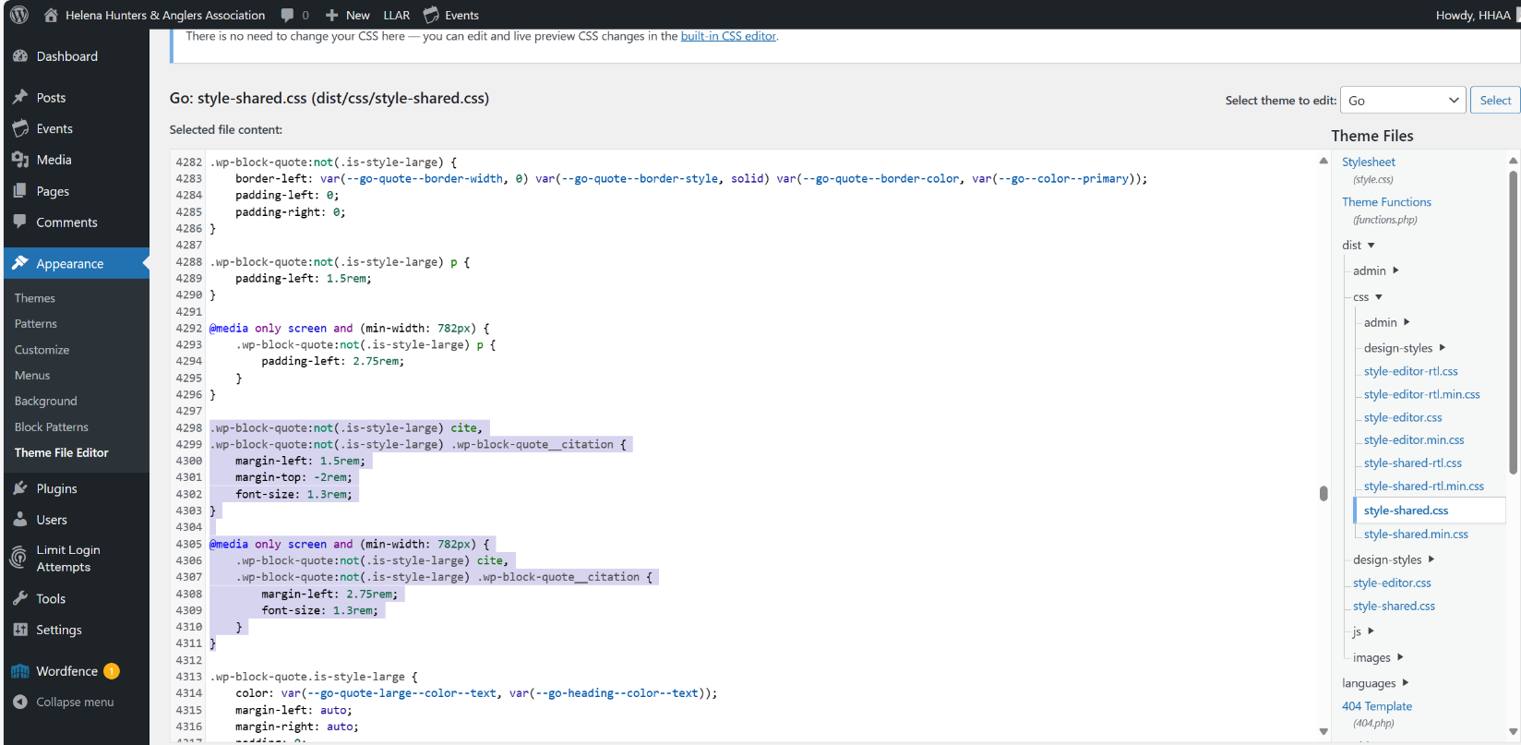

Blocking unknown IP login attempts.

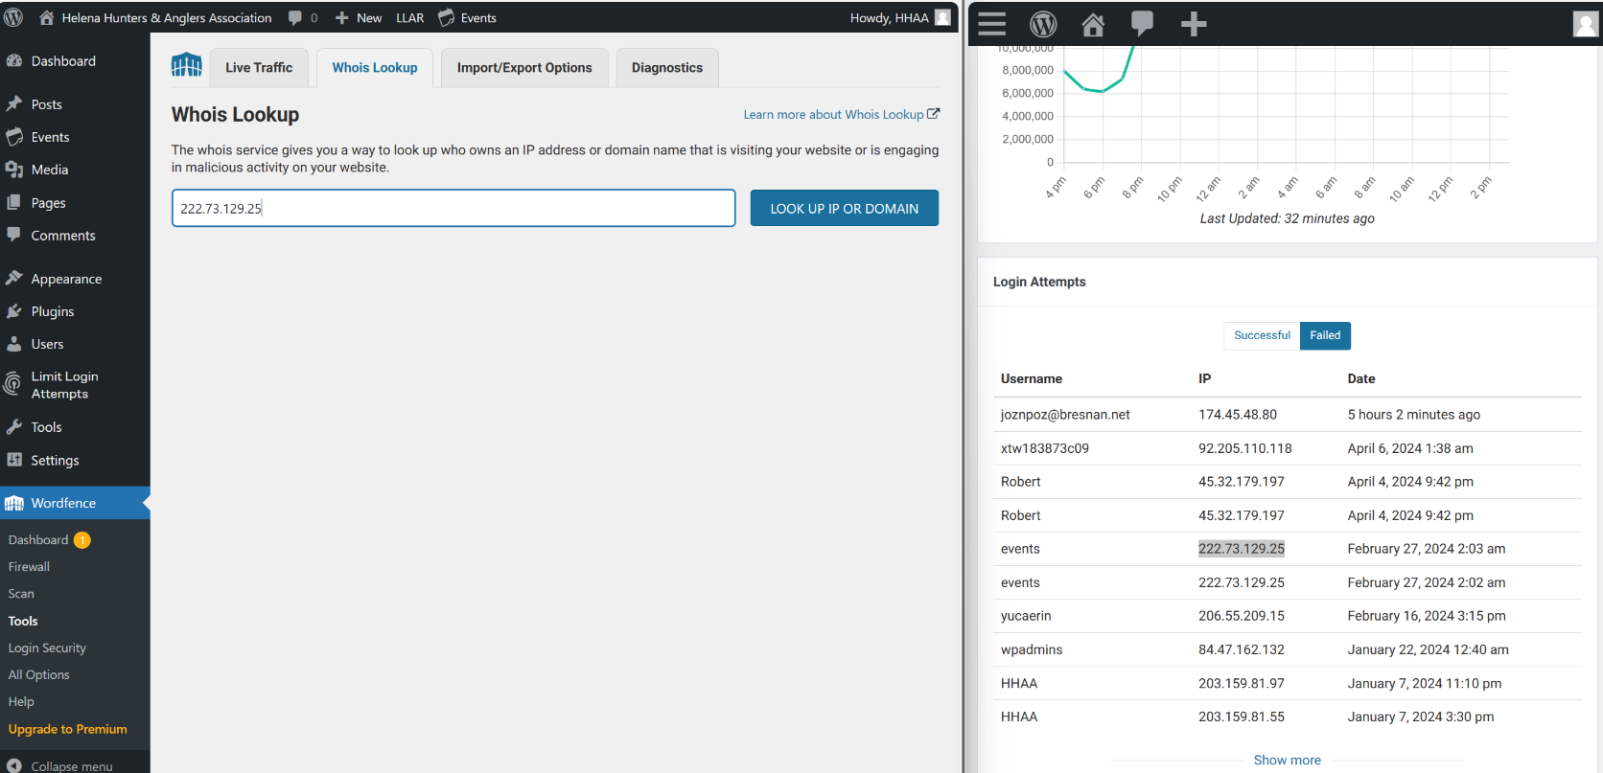

Added IPs to blocklist in Wordfence.

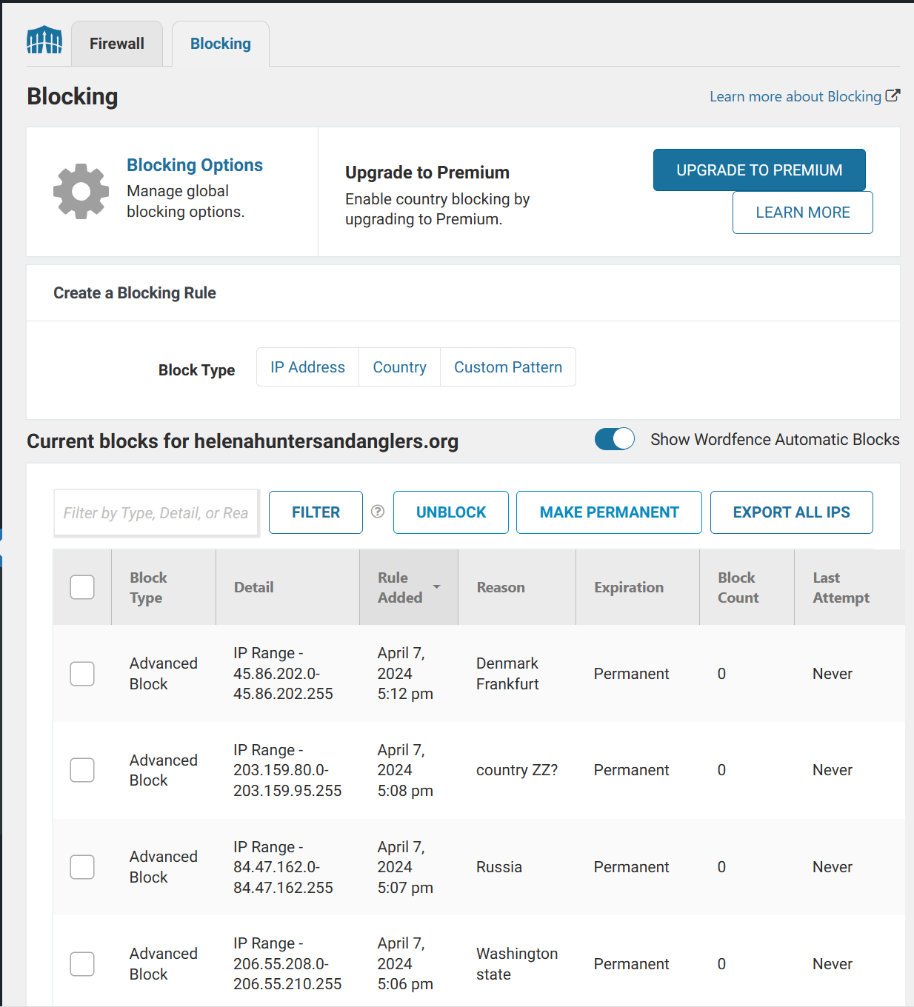

4/9/24

Wordfence live traffic blocking.

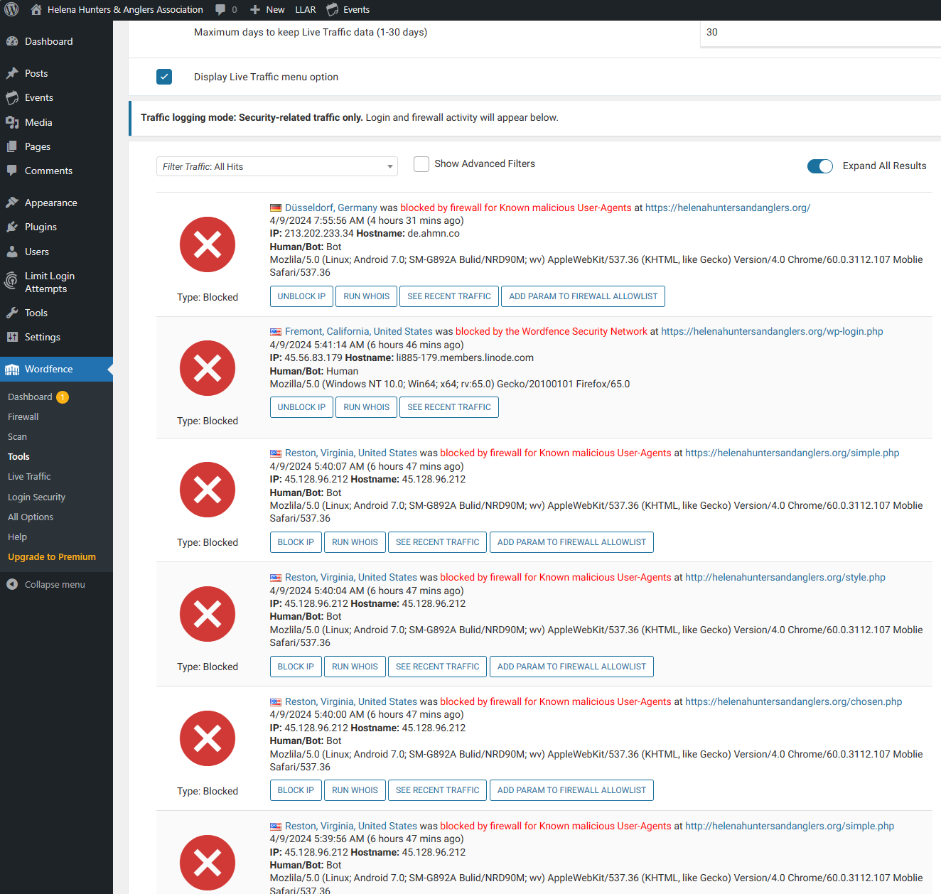

Viewing live traffic.

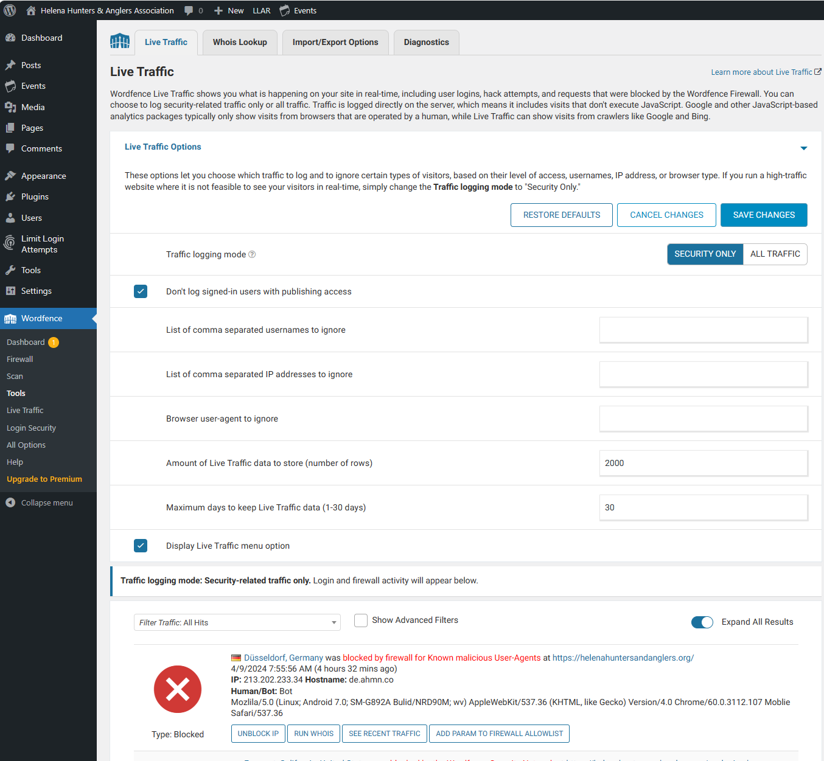

Adding to blocked list.

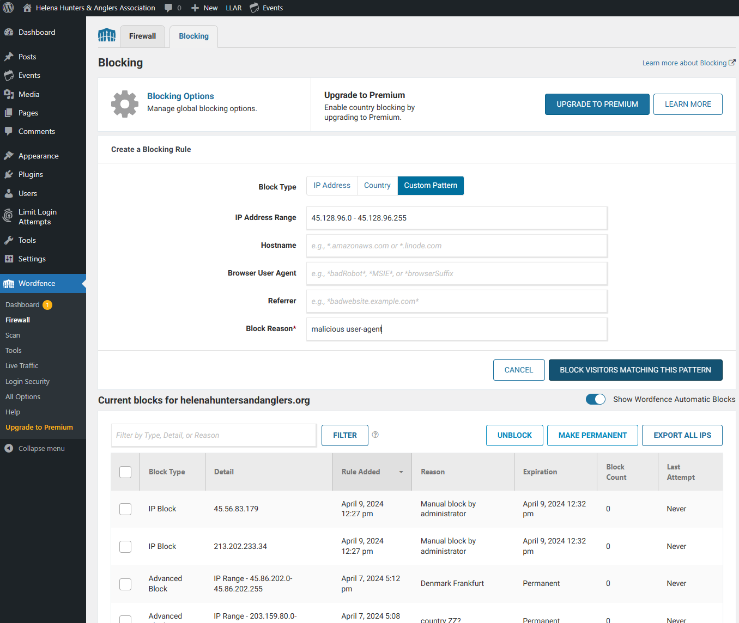

4/14/24

Events calendar update.

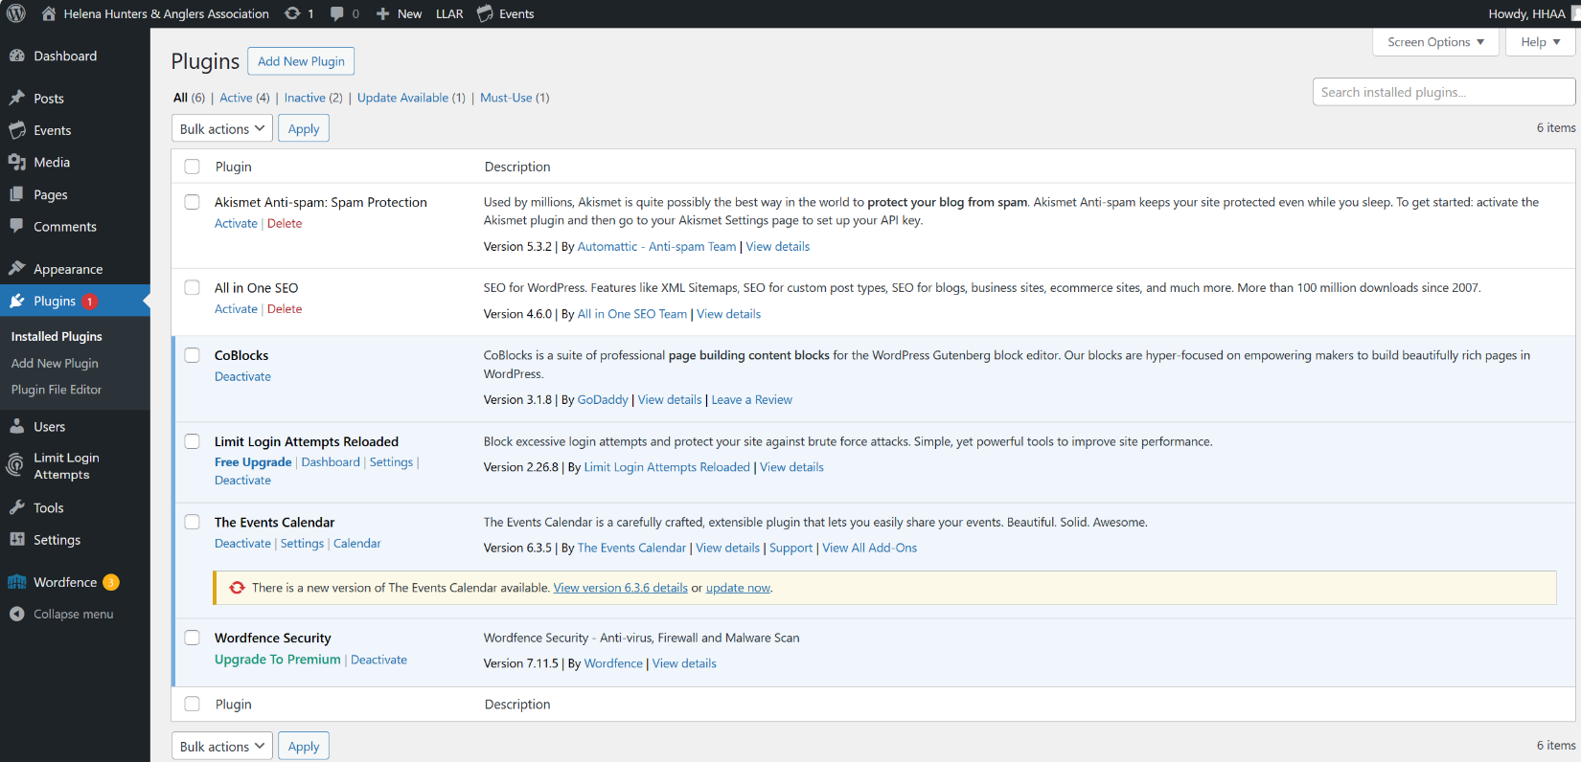

Calendar update from cPanel.

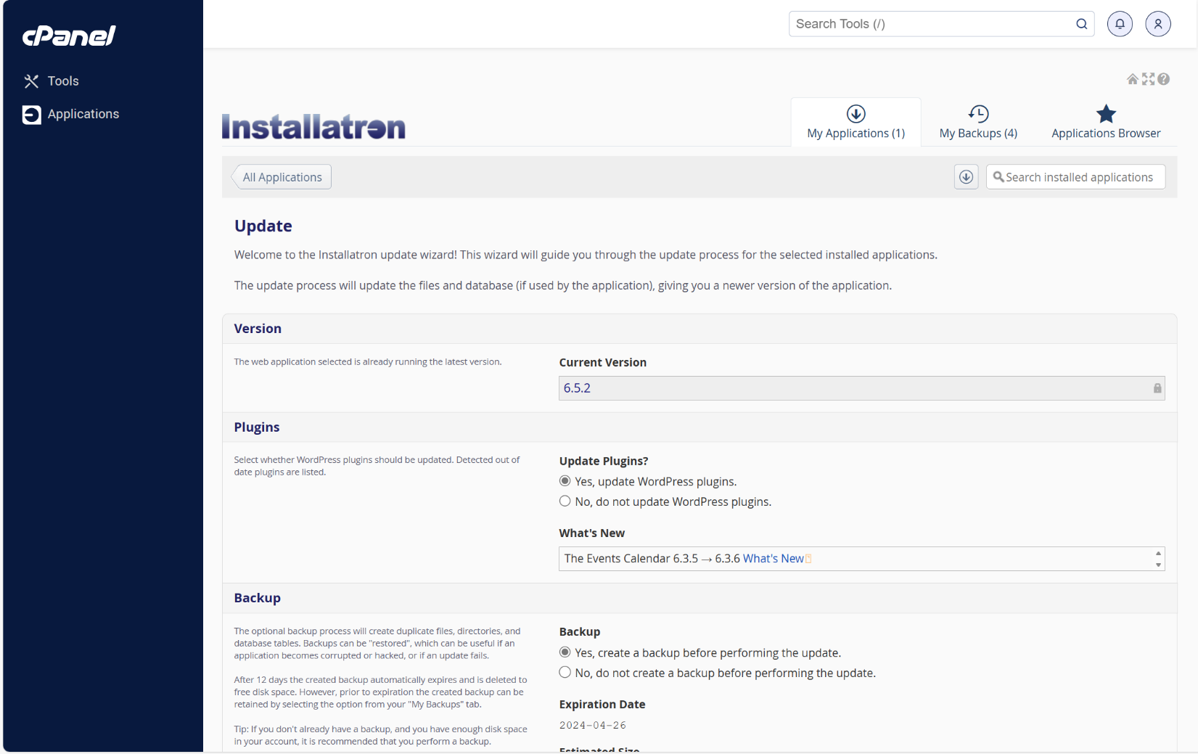

Blocking more Ips.

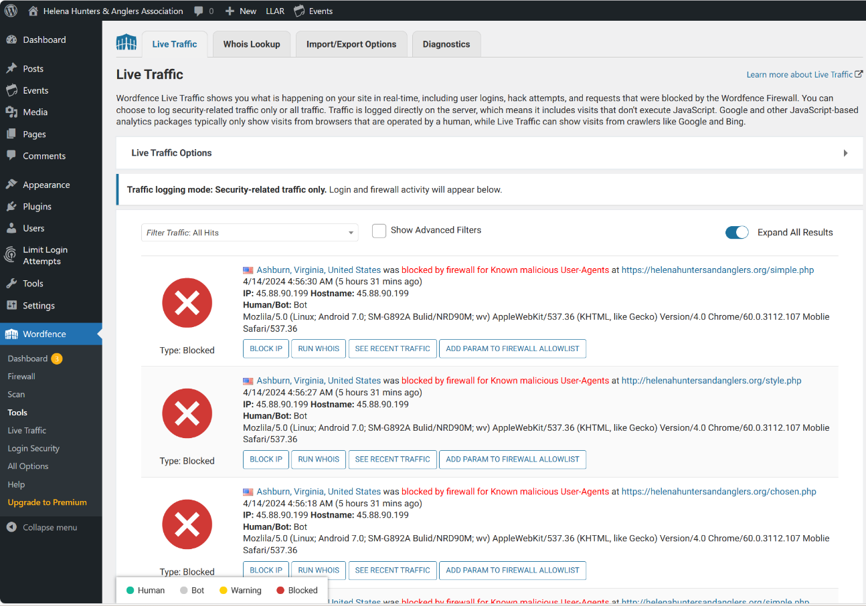

Grouped image and text to wrap text.

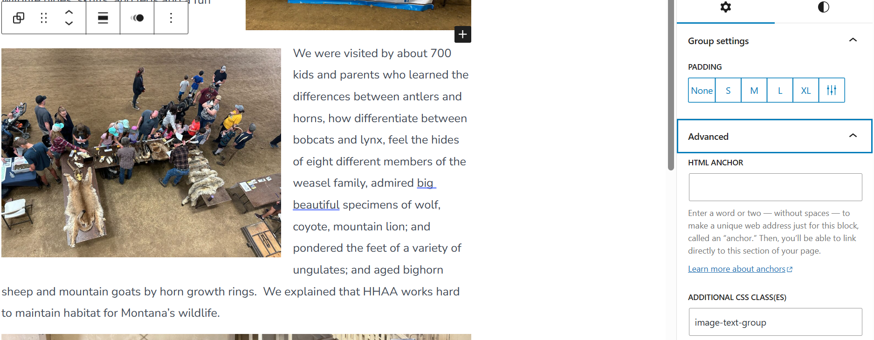

Added optional CSS class to image.

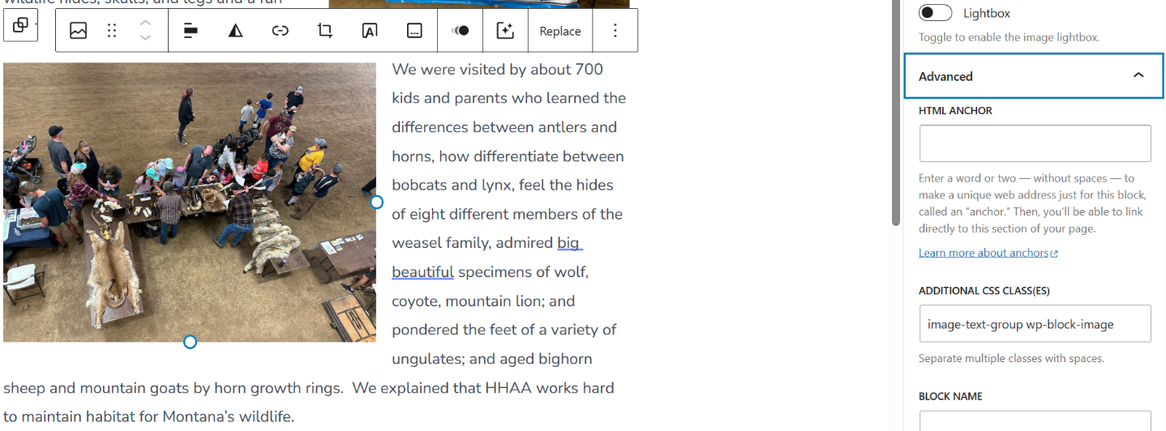

Add additional CSS classes to group image and paragraph.

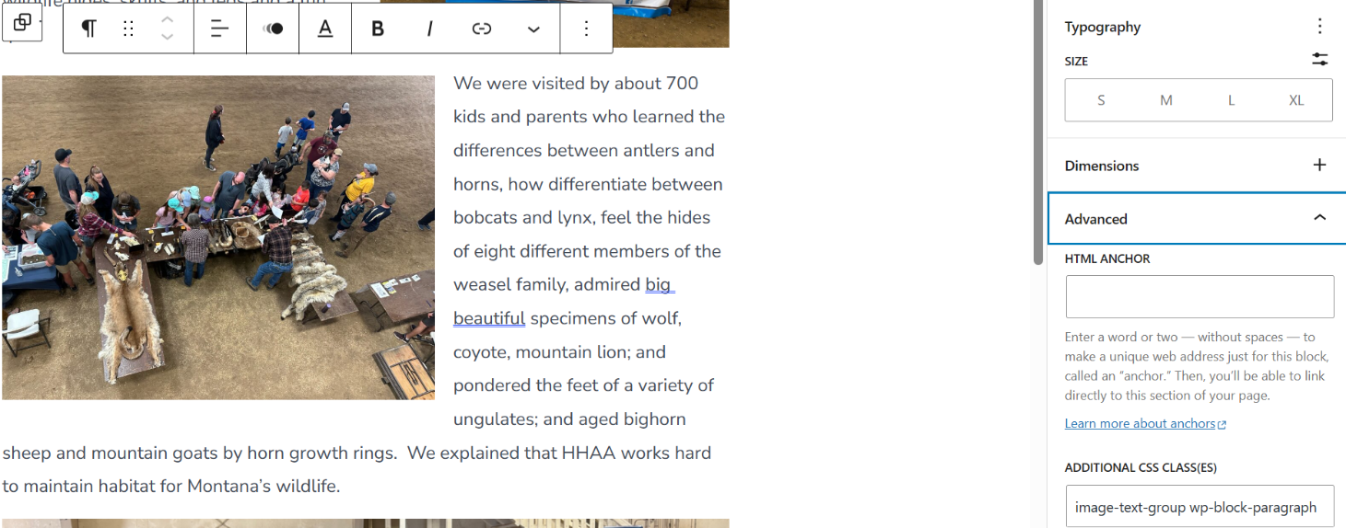

Text wrap appears in edit but not view.

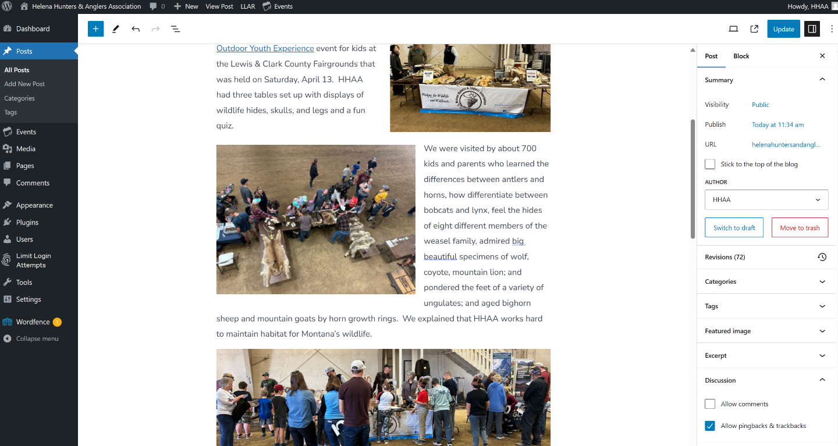

Just added separate blocks to simulate text wrapping.

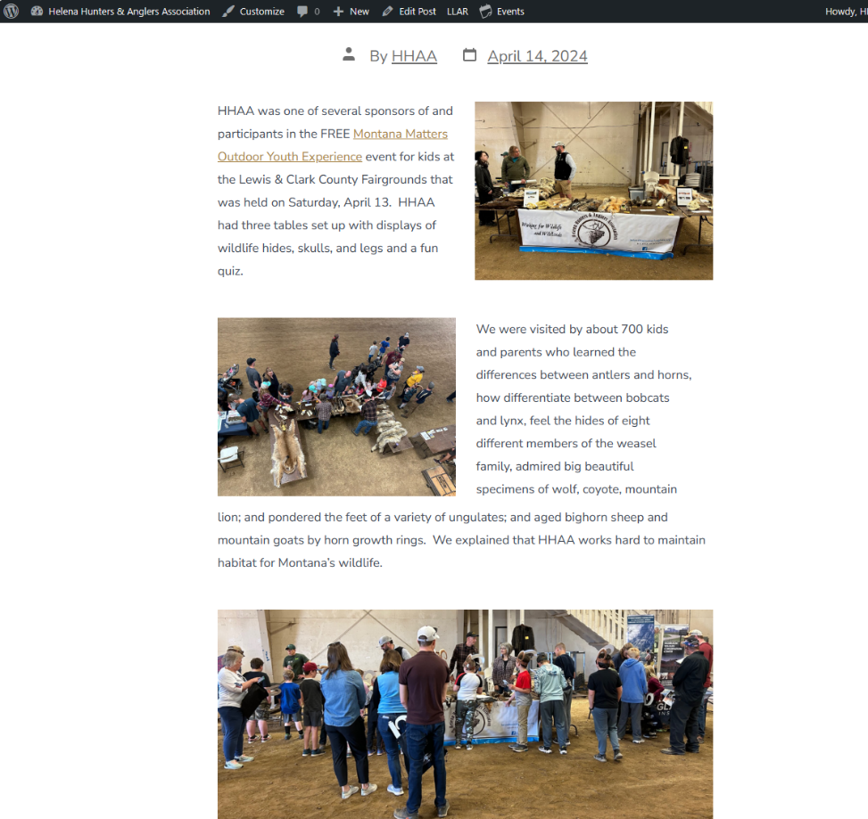

4/20/24

SEO and Events Calendar update.

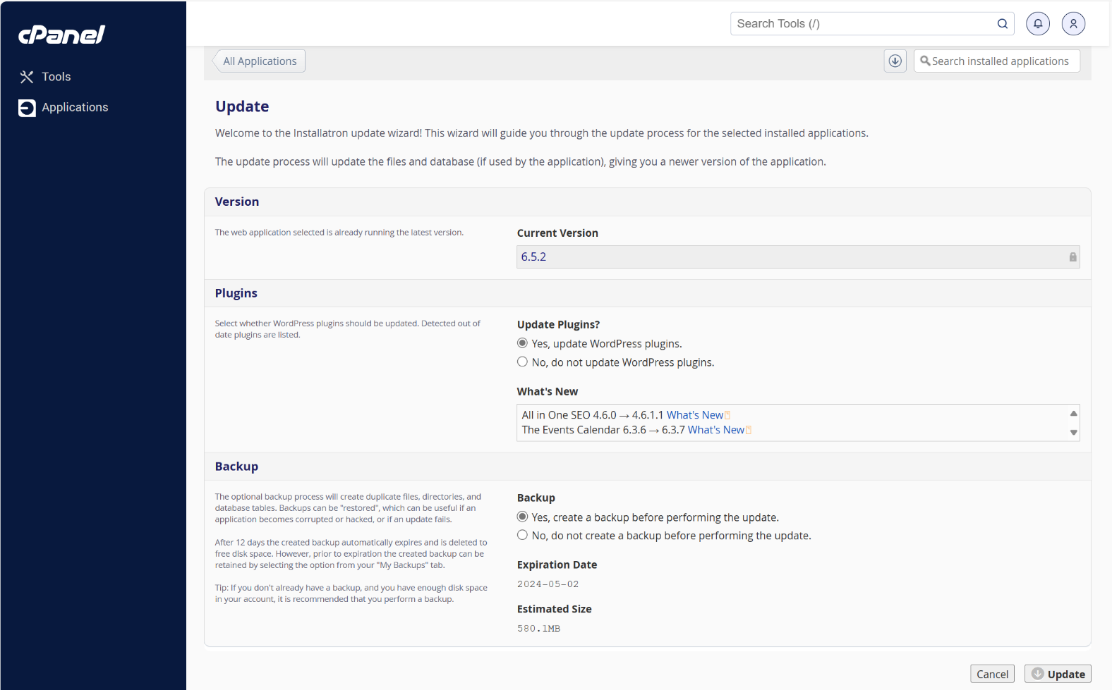

Updates complete.

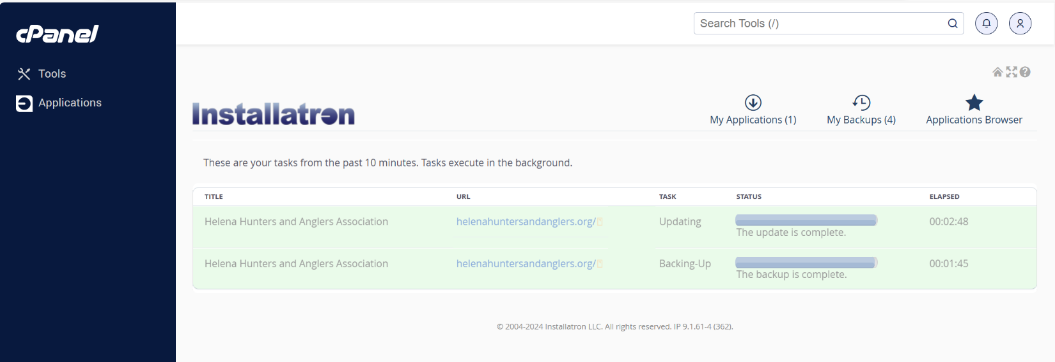

4/23/24

Changed HHAA board page heading color to white.

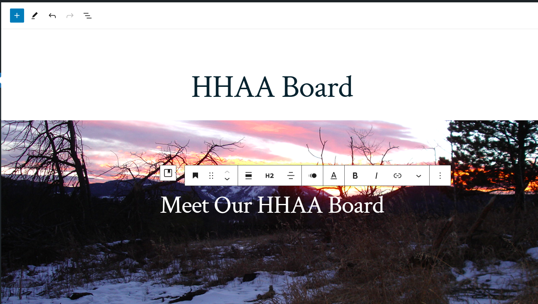

4/27/24

Moved Position Statements out of about to under Our Impact.

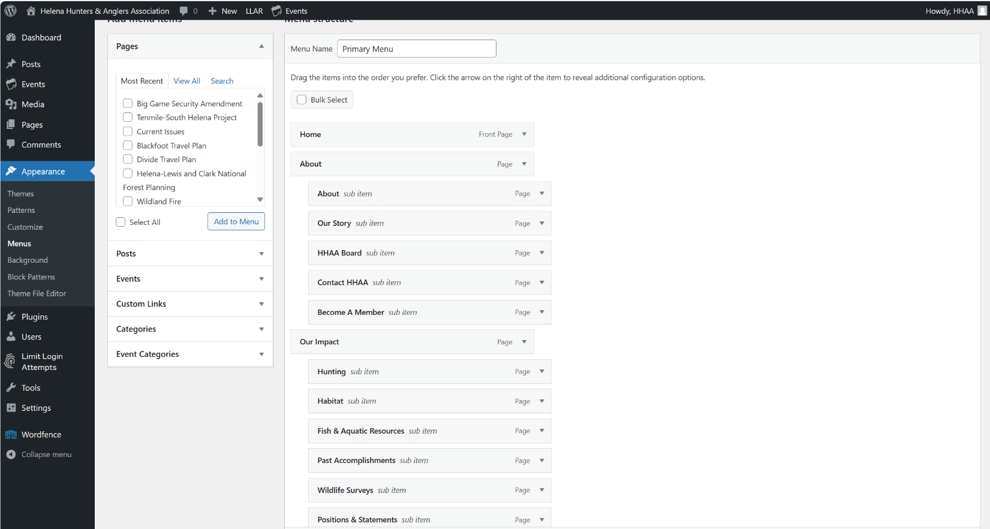

Changed Habitat and other headings to H2 customized 80px.

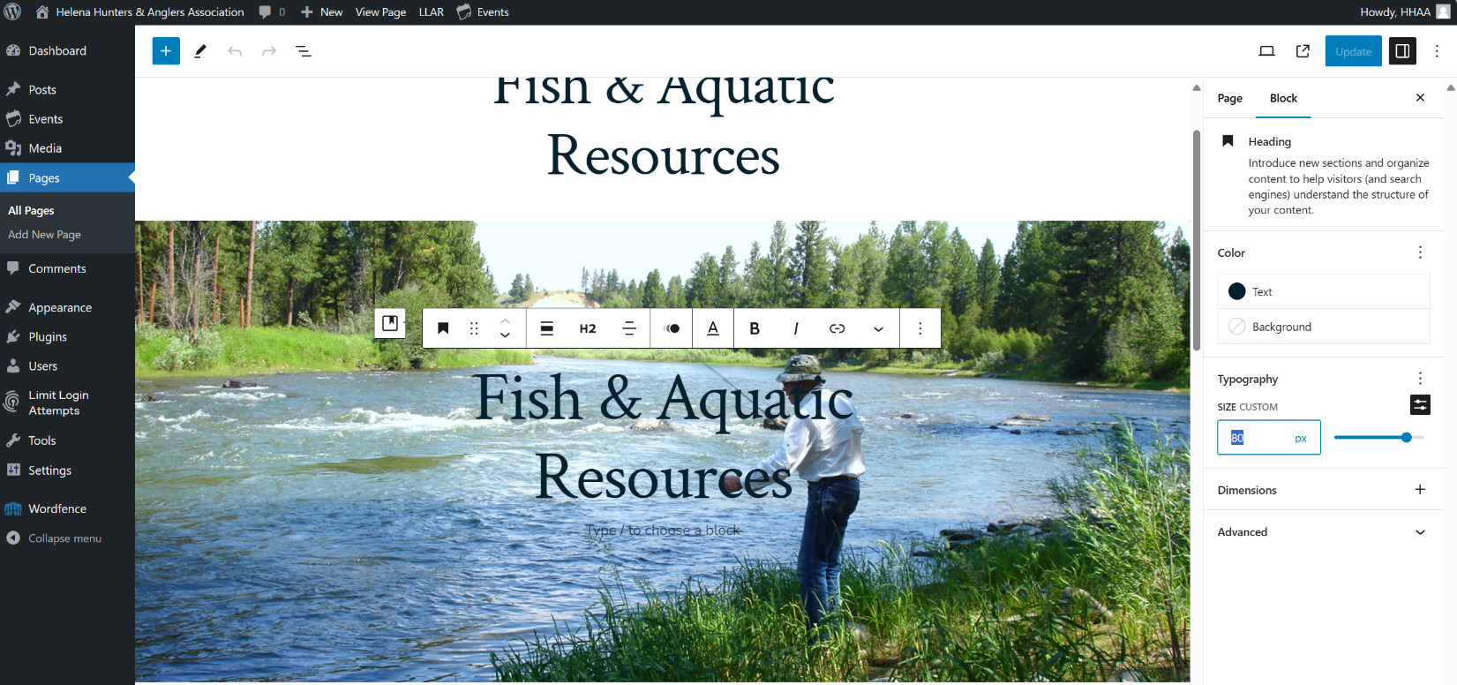

Added Wildlife page set visibility to private.

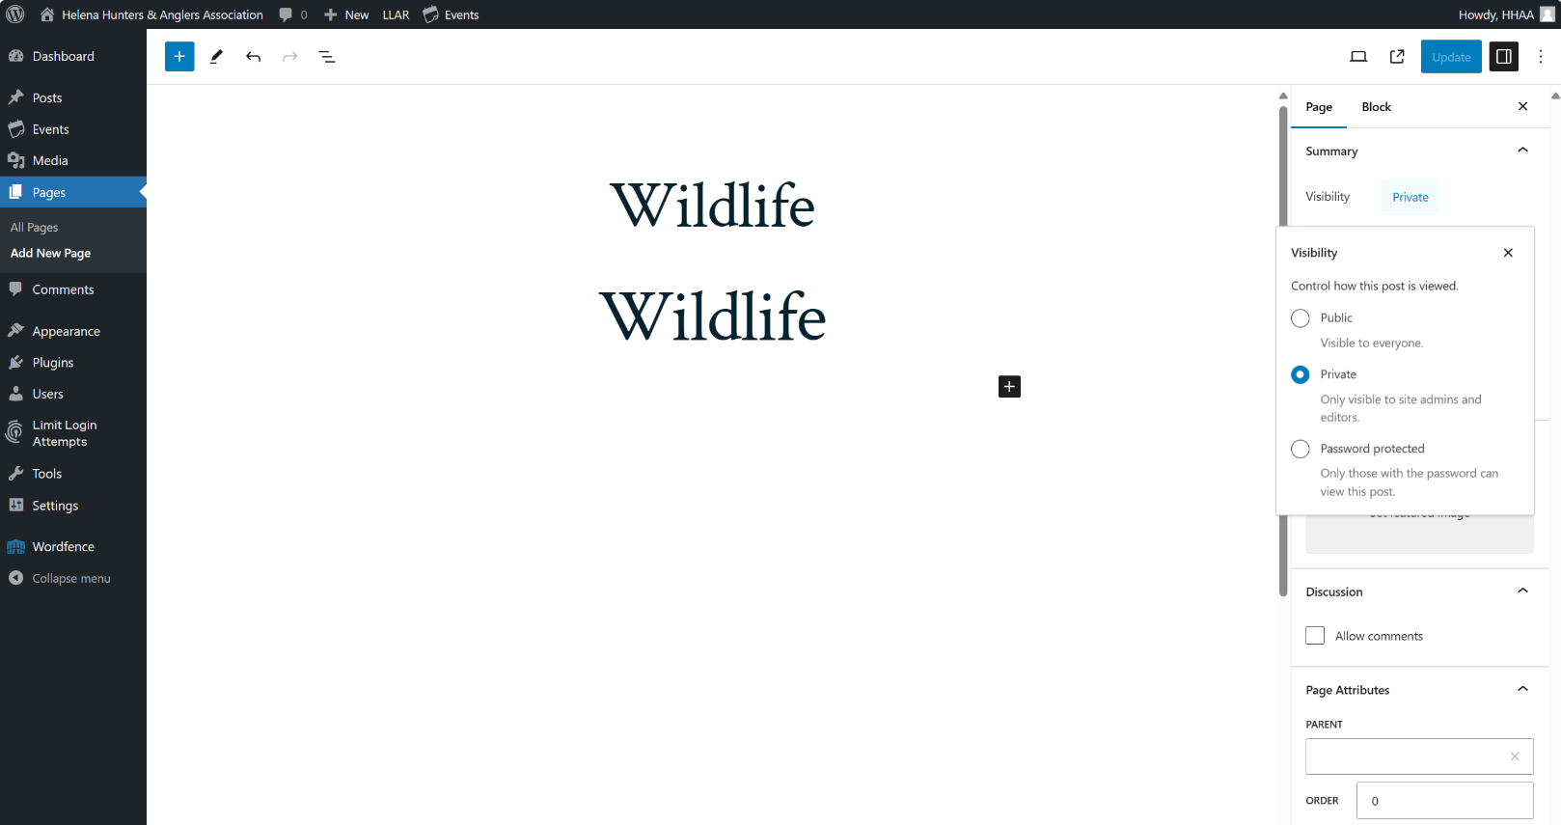

Added id attribute to wolverine section of Past Accomplishments.

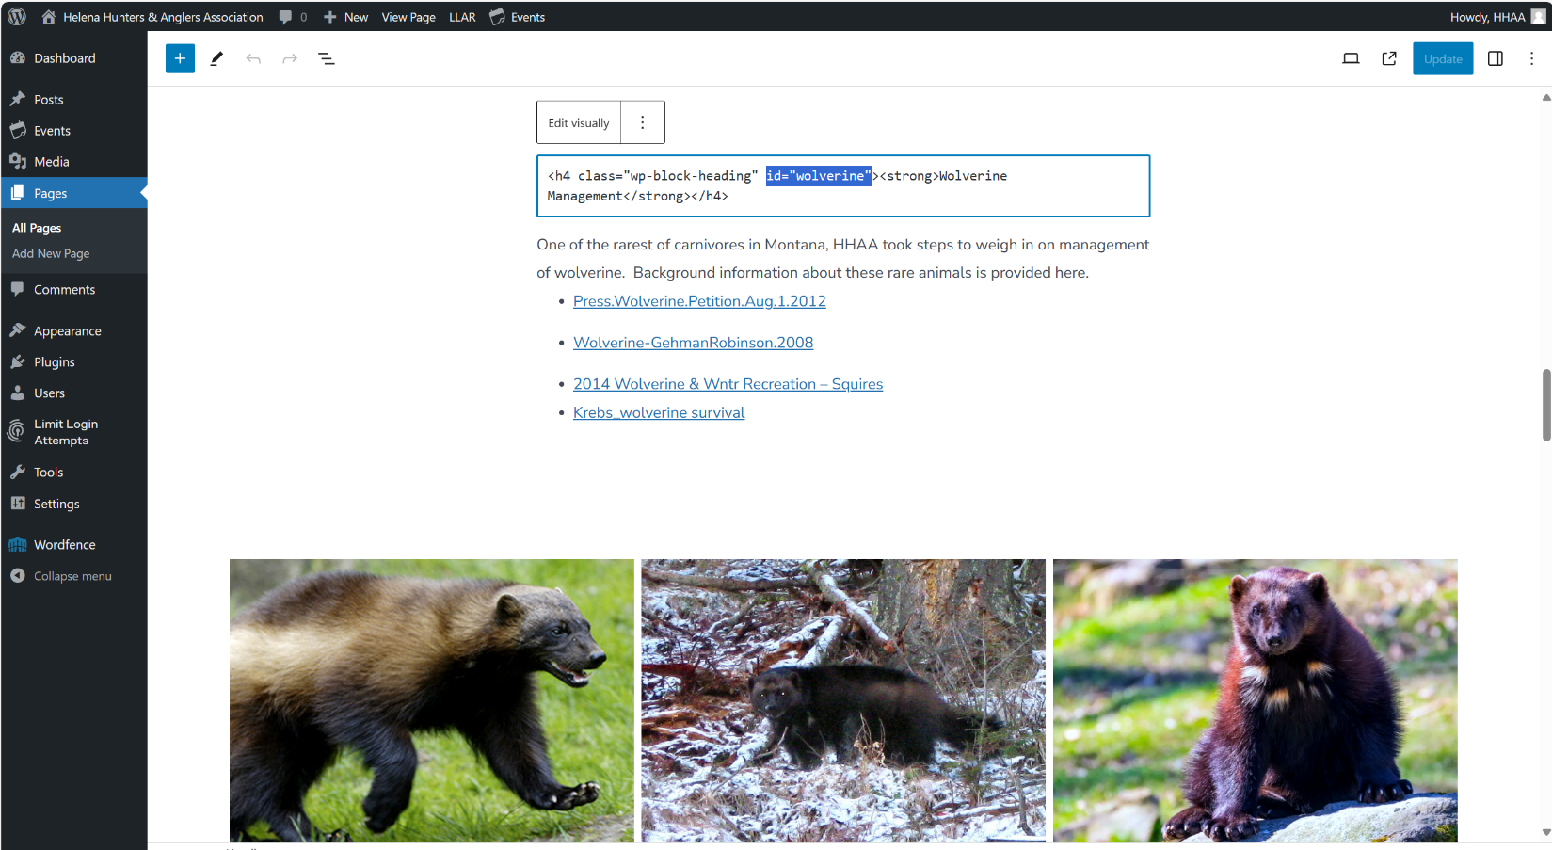

Linked to Past Accomplishments wolverine section using #wolverine id.

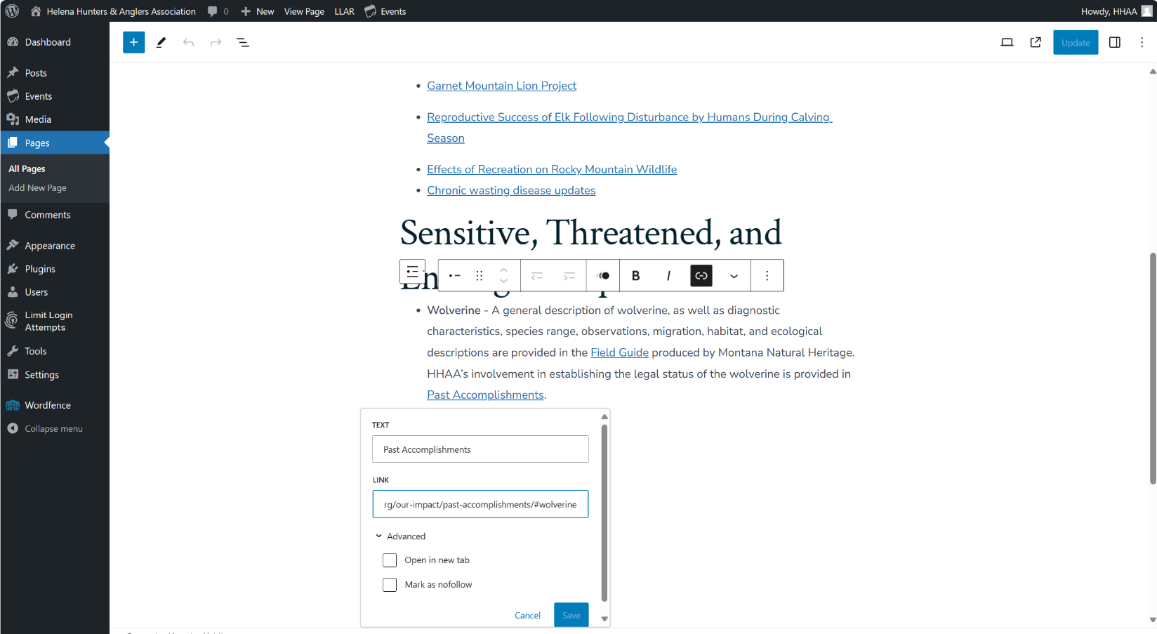

Edited quote with citation (in p tag).

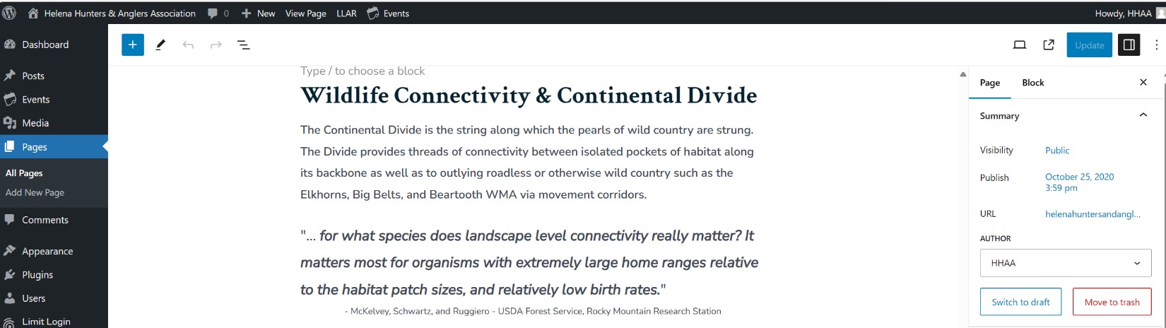

Added new page under Current Issues.

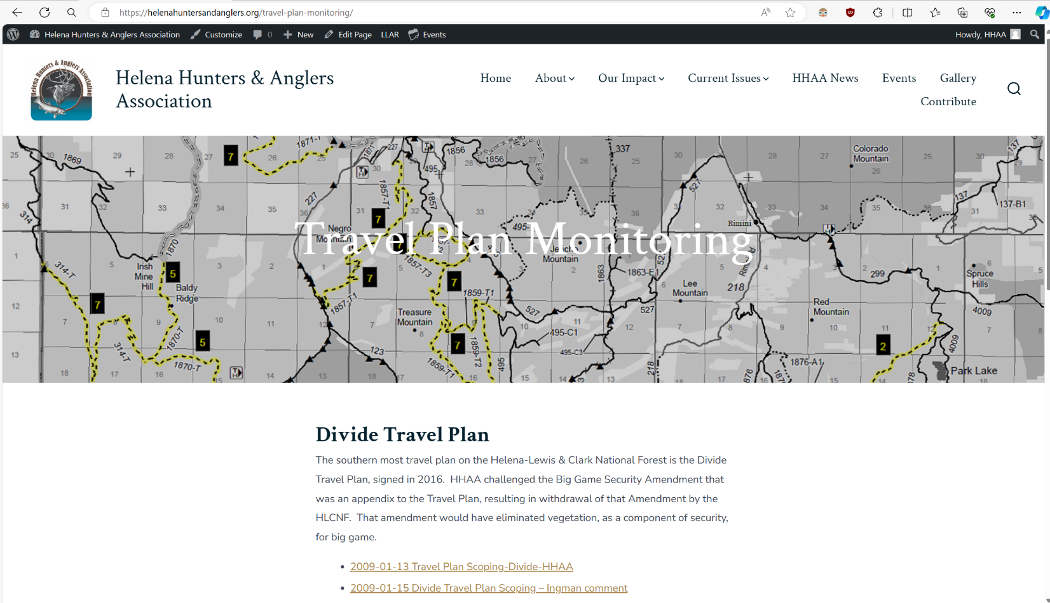

Got stuck on classic editor, but fixed.

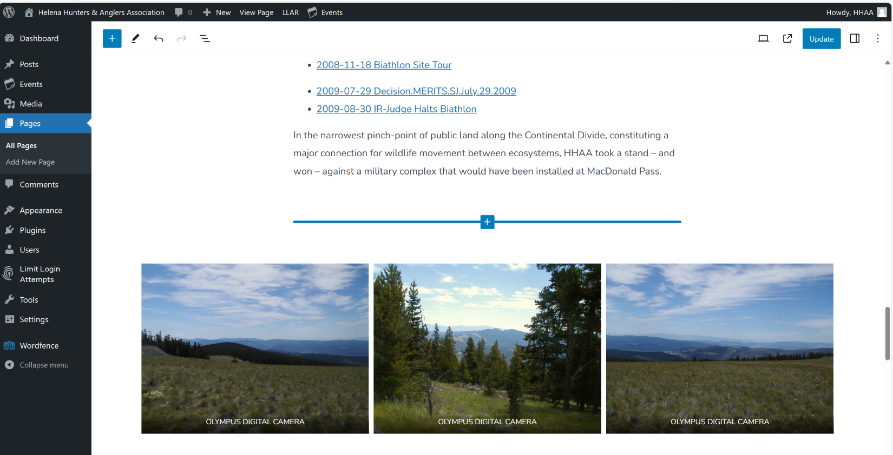

Added page.

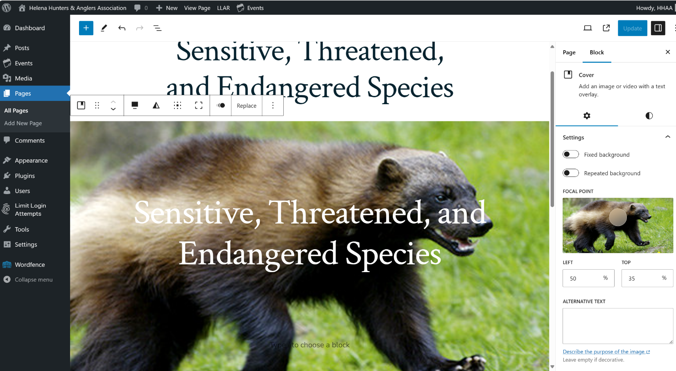

Added another page.

